Report of University Chairs Council (UCC) Student Opinion Survey (SOS) Work Group
(Membership of this work group was populated collaboratively by the UCC and FAPC.)
2.13.2012
Composition of the Work Group
Lee Gillis, Chair;
Members from UCC: Bill Fisher, Steve Auerbach, Indiren Pillay
Members identified by FAPC: Craig Turner, Carrie Cook, and Julia Metzker (replacing Karynne Kleine)

Actions of the Work Group
- The work group requested spring 2011 Student Opinion Survey data from Institutional Research. Using SPSS, Lee Gillis conducted a factor analysis of the data which revealed that the current 12 questions "load" on one factor. This can be interpreted to mean that the instrument is measuring only one aspect of teaching. (See the factor analysis on page 2.)
- The work group, with input from the Provost, identified six commercial instruments (CIEQ, SIRII (ETS), IDEA, CourseEval, eXplorance, Scantron) to investigate further using criteria of price, on-line availability, reputation, national norms, etc. (See the criteria on page 3.)
- The work group was asked to provide a range of cost estimates should the decision be made to pursue a commercial instrument. That price was estimated in the range of $40,000-$70,000 per calendar year based on an average class size of 25 and 3000 classes per calendar year.
- The work group narrowed six commercial options for further investigation to two, specifically selecting IDEA (http://www.theideacenter.org/) and SIRII (ETS) (http://www.ets.org/sir_ii/about).
- The work group formulated three recommendations.

Unanimous Recommendations of the Work Group
The work group unanimously recommends the following:
- that the locally-generated SOS form currently in use be replaced by a commercial form that has national norms and is psychometrically valid and reliable (e.g., IDEA or SIRII (ETS)).
- that the locally-generated SOS form currently in use not be replaced with a new or modified locally-generated form. Rationale for this recommendation includes issues of validity, reliability of commercial form items, comparability to peers at other institutions, and ability for customization (e.g. adding items to commercial form)
- that a work group with broader representation continue consideration of a transition to a commercial SOS form. For continuity, historical perspective, leveraging work already done, this new work group should include some members of the current UCC SOS Work Group. To broaden the representation, we suggest the inclusion of faculty representing each college and a diversity of teaching ranks (pre-tenure, post-tenure, adjunct, instructor and lecturers) as well as the inclusion of individuals with expertise in student opinion surveys and/or assessment of teaching. In addition, university officials familiar with SOS implementation logistics should inform this group or serve as members.
Note: We include summaries of the information collected for IDEA and SIRII (ETS). Should this effort be continued with the formation of another work group (committee, task force, etc.), these summaries would be a reasonable starting point for further consideration. The summaries provide the contacts at IDEA and SIRII (ETS) who provided information considered by the UCC SOS Work Group members.

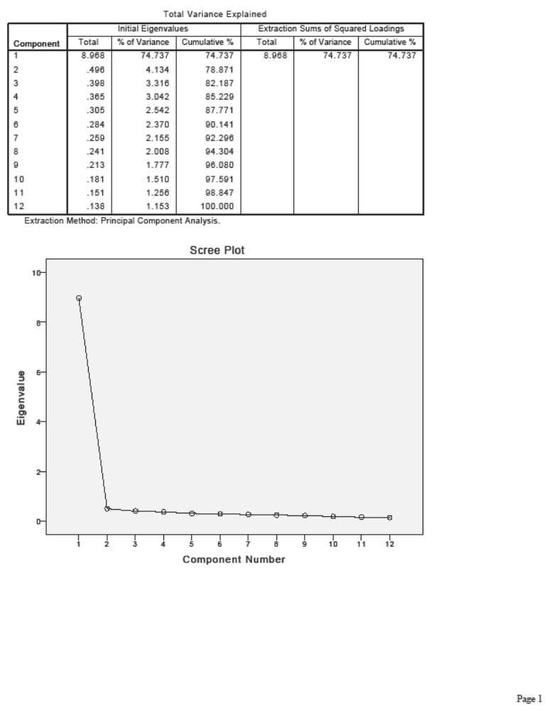

Task force: Student Opinion of Instruction
- Current Form (SOIT) and analysis
- Commercial forms – and what to collect
- Product
- Website
- On-Line
- Cost
- Reliability Psychometrics
- How many questions
- Add questions
- Who uses it
- What else?
3. Dividing and conquering from the commercial forms + timeline
Bill | CoursEval (Connectedu) | http://www.connectedu.com/products-courseval.html
Indiren | Scantron: Class Climate | http://www.scantron.com/classclimate/
Lee | Educational Testing Service (ETS): SIR II Student Instructional Report | http://www.ets.org/sir_ii/about
Carrie | eXplorance: Blue/Evalution | http://www.explorance.com/prod_evaluation.asp
Stephen | Comprehensive Data Evaluation Services CIEQ | http://www.cieq.com/index.htm
Craig | Idea Center | http://www.theideacenter.org/

Minute by Minute
Work Group History documented in UCC and Faculty Affairs Policy Committee (FAPC) minutes

At the 02/02/2011 University Chairs Council: V. New Business a) Student Opinion Survey. Discussion of Student Opinion Survey and need for committee and chair to be selected to review content.

At 03/02/2011 University Chairs Council: a) Committee Student Opinion Surveys. Lee Gillis has upcoming meeting with the Provost to discuss content, based on national psychometric and discipline-based norms. Online and graduate courses may need distinct survey questions. Senate is looking at administration and response rates. Classes over 10 will automatically be surveyed.

At the 03/30/2011 University Chairs Council: IV. Old Business a) Student Opinion Survey report by Lee Gillis following his meeting with Provost to review commercial survey products. A committee will be convened once the materials have been reviewed. Ken McGill reports that classes with less than 10 students may be surveyed at the instructor’s request; otherwise, all other classes are surveyed automatically. Ken McGill will recommend that summer classes be surveyed. There was a note that grads and undergrads evaluate differently and should be given different survey products.

At the 09/16/2011 University Chairs Council: Update on Student Opinion Form Process by Lee Gillis. Need volunteers (Steve Auerbach, Bill Fisher, & Indiren Pillay) as a time-limited group to consider commercial vendors vs. our home-grown instrument (costs, success rates, psychometrics, IT integration) to bring to Chair’s Council. Faculty Affairs Policy Committee of Senate will work with us. Concerns about quality of survey since our instrument has no proven validity. Response rate went up spring to spring. Incentives to continue to increase student response rate.

At the 10/21/2011 University Chairs Council: a) Student Opinion Form Ad-hoc Group update by Lee Gillis. Student Opinion Form Ad-hoc Group is looking at commercial forms and costs. Lee will send out data on response rates.

At the 04/29/2011 Faculty Affairs Policy Committee (organizational) meeting:
SOS Form: Committee members expressed a concern about the psychometrics of the questions in use in the on-line administration of Student Opinion Surveys (SOS). The Provost indicated that the institution’s University Chairs Council, consisting of all department chairs on campus, has a work group that is reviewing the questions on the on-line SOS form that is presently in use as the official university form and is also seeking alternatives to the current questions. This work group is expected to complete its work during the 2011-2012 academic year and circulate its recommendations and findings to appropriate governance committees including FAPC

At the 09/02/2011 Faculty Affairs Policy Committee meeting:
Student Opinion Survey Form Work Group: There was an earlier recommendation by FAPC that representatives of FAPC meet with a representative of the University Council of Chairs (Chairs Council) to determine the status of and advocate for faculty voice in their review of commercial student opinion surveys that are nationally normed with published measures of validity and reliability. The members of this work group – Karynne Kleine, Craig Turner, and Carrie Cook – met with Lee Gillis from the Chairs Council and suggested that a work group of 6-10 members, the majority faculty and the minority from Chairs Council, be formed to continue to work on this matter. This recommendation was not formally acted upon (endorsed, not endorsed) by the full committee at this meeting.

At the 10/07/2011 Faculty Affairs Policy Committee meeting:
Student opinion survey instrument review/ coordinating with University Chairs Council: A work group reporting to the University Chairs Council is examining this item. This work group is currently populated by members of the University Chairs Council (Lee Gillis (chair), Steve Auerbach, Bill Fisher, Indiren Pillay) and members of FAPC (Carrie Cook, Karynne Kleine, Craig Turner). Karynne Kleine has requested that another faculty member be considered in her place on this work group. Julia Metzker was nominated as Karynne Kleine’s replacement. The committee members present at this meeting unanimously endorsed this recommendation. A committee member requested that the work group consider whether questions added to any adopted instrument might be customizable by the department or if the university will have its own customized questions.

At the 11/04/2011 Faculty Affairs Policy Committee meeting:
NOMINATION OF JULIA METZKER TO SERVE ON THE UNIVERSITY CHAIRS COUNCIL STUDENT OPINION SURVEY WORK GROUP: Craig Turner, FAPC Chair, informed the committee that Julia Metzker accepted this nomination and is now serving as a member of the University Chairs Council Student Opinion Survey Work Group.

At the 12/2/2011 Faculty Affairs Policy Committee meeting:
Report on the work of the University Chairs Council Student Opinion Survey (SOS) Work Group: Carrie Cook provided information about the progress of the work group. She reported that the work group would meet again in January 2012 and was still in the process of gathering information about surveys from some of the companies, including information on cost and survey questions. The Provost noted that the charge of this work group was to follow up on faculty concerns (originally reported by the University Chairs Council) that the current SOS was not reliable or adequate by comparing the currently used (locally produced) SOS to several nationally vetted surveys. The result of the review would be a report to the provost on the veracity of the concerns over the reliability of the current SOS. Additionally, while collecting and reviewing sample student surveys, the provost requested that the work group collect information on the cost of the professionally prepared instruments. Provost Jordan indicated that once the report is turned into her, there will be a need to determine what, if any, additional work is needed. If the report suggests the need for a change in the SOS, a larger, more representative group (with appropriate constituent representatives) will need to be formed to move the project to the next level. If the group indicates no significant difference exists between survey instruments, there may be no need for additional discussion or action.

