2025 Standing Committee Officer Training

Table of Contents

Meeting Schedule 2

2025-26 **University Senate**Meetings 2

2026-2027 **University Senate** Organizational Meeting 2

Highlights from 2022-23 and Items on the Horizon in 2023-24 3

Academic Policy Committee (APC) 3

Belonging and Inclusion Policy Committee (BIPC) 3

Executive Committee of the University Senate (ECUS) 3

Faculty Affairs Policy Committee (FAPC) 3

Resources, Planning, and Institutional Policy Committee (RPIPC) 3

Student Affairs Policy Committee (SAPC) 3

Sub-Committee on Nominations (SCoN) 3

Standing Committee Officer Training (elected officers of senate committees) 3

Standing Committee Officer Responsibilities 3

Standing Committee Chairs 3

Standing Committee Vice-Chairs 4

Standing Committee Secretaries 4

Responsibilities to be Assigned or Defined by the Committee 4

Pertinent University Senate Bylaws 4

Ongoing Committee Reminders 5

Standing Committee Scopes 5

Required Written Reports 6

Committee Chair to University Senate 6

Committee Annual Report 6

Standing Committee Chairs with Executive Committee 6

Purposes of Motions 6

University Senate Website Navigation 7

University Senate Management System: Log in with UNIFY username and password 7

Accessing and Utilizing the Motion Database 8

Accessing and Submitting Meeting Agenda through the File Repository 10

Submission of Minutes 12

# Meeting Schedule

### 2025-2026 **University Senate**, Standing Committee, and *ECUS with* *Standing Committee Chairs Meetings*

* Friday 25 Apr 2025 3:30-4:45pm Arts & Sciences 272: University Senate Organizational Meeting
* Mon 11 Aug 2025 9:00-2:00pm TBA: Governance Retreat, including Standing Committee Organizational Meetings
* Friday 5 Sep 2025 2:00-3:15pm Standing Committees: APC, BIPC, ECUS, FAPC, RPIPC, SAPC
* Friday 5 Sep 2025 3:30-4:45pm Parks 301: ECUS with Standing Committee Chairs
* Friday 19 Sep 2025 3:30-4:45pm Arts & Sciences 272: University Senate
* Friday 3 Oct 2025 2:00-3:15pm Standing Committees: APC, BIPC, ECUS, FAPC, RPIPC, SAPC
* Friday 3 Oct 2025 3:30-4:45pm Parks Hall 301: ECUS with Standing Committee Chairs
* Friday 17 Oct 2025 3:30-4:45pm Arts & Sciences 272: University Senate
* Friday 31 Oct 2025 2:00-3:15pm Standing Committees: APC, BIPC, ECUS, FAPC, RPIPC, SAPC
* Friday 31 Oct 2025 3:30-4:45pm Parks Hall 301: ECUS with Standing Committee Chairs
* Friday 14 Nov 2025 3:30-4:45pm Arts & Sciences 272: University Senate
* Friday 9 Jan 2026 2:00-3:15pm Standing Committees: APC, BIPC, ECUS, FAPC, RPIPC, SAPC
* Friday 9 Jan 2026 3:30-4:45pm Parks Hall 301: ECUS with Standing Committee Chairs
* Friday 23 Jan 2026 3:30-4:45pm Arts & Sciences 272: University Senate
* Friday 13 Feb 2026 2:00-3:15pm Standing Committees: APC, BIPC, ECUS, FAPC, RPIPC, SAPC
* Friday 13 Feb 2026 3:30-4:45pm Parks Hall 301: ECUS with Standing Committee Chairs
* Friday 27 Feb 2025 3:30-4:45pm Arts & Scences 272: University Senate
* Friday 6 Mar 2025 2:00-3:15pm Standing Committees: APC, BIPC, ECUS, FAPC, RPIPC, SAPC
* Friday 6 Mar 2025 3:30-3:15pm Parks Hall 301: ECUS with Standing Committee Chairs
* Friday 27 Mar 2025 3:30-4:45pm Arts & Sciences 272: University Senate
* Friday 3 Apr 2025 2:00-3:15pm Standing Committees: APC, BIPC, ECUS, FAPC, RPIPC, SAPC
* Friday 3 Apr 2025 3:30-4:45pm Parks Hall 301: ECUS with Standing Committee Chairs
* Friday 24 Apr 2025 2:00-3:15pm Arts & Sciences 272: University Senate

### 2026-2027 **University Senate** Organizational Meeting

* Friday 24 Apr 2025 3:30-4:45pm Arts & Sciences 272: University Senate Organizational Meeting

# Highlights from 2024-25 and Items on the Horizon in 2025-26

## [Academic Policy Committee (APC)](https://senate.gcsu.edu/committee/apc)

## [Belonging and Inclusion Policy Committee (BIPC)](https://senate.gcsu.edu/committee/deipc)

## [Executive Committee of the University Senate (ECUS)](https://senate.gcsu.edu/committee/ecus)

## [Faculty Affairs Policy Committee (FAPC)](https://senate.gcsu.edu/committee/fapc)

## [Resources, Planning, and Institutional Policy Committee (RPIPC)](https://senate.gcsu.edu/committee/rpipc)

## [Student Affairs Policy Committee (SAPC)](https://senate.gcsu.edu/committee/sapc)

## Sub-Committee on Nominations (SCoN)

# Standing Committee Officer Training (elected officers of senate committees)

## Standing Committee Officer Responsibilities

### Standing Committee Chairs

* + - Eligibility: Elected Faculty Senators who are members of the standing committee
    - Post standing committee meeting agendas to the Senate website. Email the [US secretary](mailto:alex.blazer@gcsu.edu) written reports after ECUS-SCC and University Senate meetings.
    - Bylaws Responsibilities:
      * + Present Committee Report to University Senate at scheduled University Senate meetings (Article II, Sec 3.A.3)
        + Submit such reports to University Senate Secretary in appropriate format for minutes (Article II Section 3.I)
        + Transfer committee records to the following year's committee (Article IV, Sec 3.B)
        + Meet regularly with the Executive Committee and other chairs to facilitate communication (Article V, Sec 1.C.14)
        + Serve on the Subcommittee on Nominations (Article V, Sec 1.D.1.a)
        + Be notified by a committee member who is going on extended leave (Article II Section 3.H)
        + Be consulted by ECUS on due date and format of comprehensive annual report of committee (Article IV, Sec 2)
        + Be consulted by ECUS on steering any matter to a standing committee (Article V, Sec 1.C.4)
    - Other Responsibilities:
      * + Be contacted by committee members extending regrets prior to the meeting
        + Others as defined by the committee

### Standing Committee Vice-Chairs

* Eligibility: Any member of the standing committee
* Bylaws Responsibilities: None
* Other Responsibilities:
* Assumes all duties and responsibilities of the Committee Chair in the absence of the Committee Chair
* To be defined by the committee

### Standing Committee Secretaries

* Eligibility: Any member of the standing committee
* Post standing committee meeting minutes to the Senate website.
* Bylaws Responsibilities: The secretary of the committee shall post the minutes of a committee meeting prior to the call to order of the next meeting of the committee. This includes minutes of any subcommittee or ad hoc committee that reports to it. (Article V, Section 2.B.3)
* Other Responsibilities:
* Be contacted by committee members extending regrets prior to the meeting
* To be defined by the committee

## Responsibilities to be Assigned or Defined by the Committee

* Chairs or secretaries, please email the [US secretary](mailto:alex.blazer@gcsu.edu) approved operating procedures and he will post them to the Senate website
* When a vacancy on the committee occurs, a replacement determined in same manner
* Scheduling meeting rooms, times, and dates for committee meetings
* Conducting meetings (preside at meetings)
* Conducting forums
* Supplying an agenda for committee meetings with electronic documentation
* **Establishing operating policies/procedures and filing with ECUS**
* Writing and submitting a comprehensive, written annual report
* Entering motions in the online motion database to get a motion on the floor of Senate
* Ad hoc committee registry form submission
* Advertising Meeting Times and Agenda to the University Community
* Promoting the Governing Concepts of the University Senate in order to increase the university community’s capacity for shared governance

## Pertinent University Senate Bylaws

* IV.Section3.A. Organizational Meetings. Within ten (10) calendar days of the spring organizational meeting of the incoming University Senate for the subsequent academic year, each of the incoming standing committees shall hold a meeting at which they elect committee officers in accordance with V.Section2.B.1. The Executive Committee shall designate a facilitator to both preside at this meeting and conduct the elections of the committee officers. Should there be any unfilled positions on the incoming committee, specifically members not known by name such as SGA appointees, Presidential Appointees named by title, etc., the Executive Committee shall name voting proxies for the elections of the committee officers from the pool of outgoing committee members.
* V.Section2.B.1. Officers. The members of a standing committee shall elect a chair, a vice-chair, and a secretary by secret ballot in accordance with IV.Section3.A. Only elected faculty senators are eligible to serve as the committee chair, but any member of the committee is eligible to serve as vice-chair or secretary. The chair, vice-chair, and secretary shall be elected for a period of one year. The chair, vice-chair, or the secretary may be reelected.

## Ongoing Committee Reminders

* Options for **working groups**
  + subcommittees (requires bylaws change),
  + ad hoc committee (formal – Bylaws V.Section2.A.3.b. requires a charter in consultation ECUS)
  + information gathering group (informal)
* Be intentional on **sharing information with the entire University Community**. This might include the identification of particular committee members to share information with students, staff, faculty, administration.
* **Copy monthly committee meeting agenda** to standing committee chairs executive committee when distributing it to committee members to keep all in the information loop.
* **Upload monthly committee meeting agenda** to Senate website.
* At the end of each monthly meeting, consider having the secretary summarize the meeting (this allows committee members to clarify the draft minutes while the meeting is still “fresh” in their minds).
* At the end of each monthly meeting, consider setting tentative agenda of the following meeting.
* Consider **overflow meeting time** when drafting/revising committee operating procedures.

FYI: From 11-21-06 ECUS meeting: Suggested that for both the larger group and Standing Committees that when motions are made that someone other than the presiding officer (such as the Administrative Assistant or Past Presiding Officer) track and display in a prominent way the motion statement in the meeting room reflecting any amendments to a motion so that Senators or committee members are able to see the exact motion statements including amendments made from the floor during debate and when they vote on the motions.

## Standing Committee Scopes

* V.Section2.C.1.b. *Scope*. The **Academic Policy Committee** shall review and recommend for or against policy relating to undergraduate and graduate education matters that have broad impact or implication to the university as a whole, which includes, but is not limited to, policies relating to grading, scholastic probation and honors, academic appeals, academic standing, standards for admission, academic calendar, and academic ceremonies. This committee also provides advice, as appropriate, on academic procedural matters at the institution.
* V.Section2.C.2.b. *Scope*. The **Belonging and Inclusion Policy Committee** shall review and recommend for or against policy related to inclusion and belonging which includes, but is not limited to, policies relating to all institutional aspects of fair treatment of all university members regarding accessibility, opportunities, and resources considering the different circumstances each member faces; the success and education of the university community on issues of inclusion, belonging, state laws, and federal laws regarding protected classes; and university language relating to non-discrimination and difference. In addition, this committee shall review and provide advice on procedures, guidelines, and employee and student professional development relating to institutional climate and priorities for ensuring just and impartial treatment of all members of the university.
* V.Section2.C.3.b. *Scope*. The **Faculty Affairs Policy Committee** shall review and recommend for or against policy relating to faculty welfare (e.g. authorities, responsibilities, rights, recognitions, privileges, and opportunities), which includes, but is not limited to, policies relating to academic freedom, workload, compensation, recruitment, retention, promotion, tenure, recognitions, development, and instructional support. This committee also provides advice, as appropriate, on procedural matters that affect the welfare of the faculty.
* V.Section2.C.4.b. *Scope*. The **Student Affairs Policy Committee** shall review and recommend for or against policy relating to the general social, cultural, and practical welfare of students, which includes, but is not limited to, policies relating to non-academic areas such as conduct and discipline, grievances and non-academic appeals, financial aid, human services for students (e.g. health center, counseling), organizations, awards, intercollegiate athletics, and other extracurricular activities (e.g. Greek life, residence life, intramurals). This committee also provides advice, as appropriate, on procedural matters that affect the general social, cultural, and practical welfare of the students.
* V.Section2.C.5.b. *Scope*. The **Resources, Planning, and Institutional Policy Committee** shall review and recommend for or against policy relating to non-instructional personnel (including administrative personnel) and institutional budget and planning functions, which includes, but is not limited to, policies relating to recruitment, hiring, evaluation, welfare and development as well as compliance with local, state, and federal guidelines (e.g. affirmative action, ADA, homeland security), and institutional support functions of the university (e.g. technology, parking) In addition, this committee shall review and provide advice on master planning, strategic planning, and budgeting processes and provides advice, as appropriate, on other procedural matters that affect the general welfare of the institution and its employees.

## Required Written Reports

### Committee Chair to University Senate

* II.Section3.A.3. *Reports.* Each standing committee and the Executive Committee, through its duly elected chair, shall, at all regular meetings of the University Senate, make a brief oral report of business transacted by the committee since the previous meeting of the University Senate. In addition, II.Section3.I. applies to such reports.
* II.Section3.I. *Reports.* All reports given at a University Senate meeting shall be submitted in an appropriate format to the Secretary of the University Senate for inclusion in the minutes of that meeting.
* [Minutes Template](https://senate.gcsu.edu/us/about-university-senate/minutes-template)

### Committee Annual Report

* + - IV.Section 2. *Reports*. The committees listed in V.Section2.A.1 shall constitute the standing committees of the University Senate. Each standing committee and the Executive Committee shall present a comprehensive, written, annual report in an appropriate format to the Executive Committee. This report shall include a summary of the major items considered by the committee during the academic year and the disposition of each. The Executive Committee shall set a due date and the format of these reports in consultation with the standing committee chairs and these reports shall be posted with the minutes of the last University Senate meeting of the academic year.
    - [Annual Report Template](https://senate.gcsu.edu/sites/default/files/public-repository/AR_Template.docx)
    - [Annual Reports Archive](https://us.gcsu.edu/Annual_Reports/index.htm)

### Standing Committee Chairs with Executive Committee

* V.Section1.C.14. Standing Committee Chairs Coordination. The Executive Committee shall meet regularly with the Standing Committee Chairs to facilitate communication among the committees of the University Senate.
* In practice, at the joint meetings of the Standing Committee Chairs with Executive Committee, each standing committee chair provides a brief oral report. While not formally required by bylaws, submitting those reports electronically (email or MSWord format) to ECUS secretary is desirable (to the ECUS Secretary).

## Purposes of Motions

* To RECOMMEND revisions to an existing policy
* To RECOMMEND revisions to existing University Senate Bylaws
* To ENDORSE procedural recommendations (more of a resolution than a motion; outside purview)
* To ENDORSE a resolution
* To RECOMMEND a new policy:
* [Policy Template](https://nam11.safelinks.protection.outlook.com/?url=https%3A%2F%2Fsenate.gcsu.edu%2Fus%2Fabout-university-senate%2Fpolicy-template&data=05%7C01%7Crobert.sumowski%40gcsu.edu%7C4dae2c039244497046e508db98578c5a%7Cbfd29cfa8e7142e69abc953a6d6f07d6%7C0%7C0%7C638271274377021329%7CUnknown%7CTWFpbGZsb3d8eyJWIjoiMC4wLjAwMDAiLCJQIjoiV2luMzIiLCJBTiI6Ik1haWwiLCJXVCI6Mn0%3D%7C3000%7C%7C%7C&sdata=u03TiP0v0rqELO1dB8Wf6yZ3tyr3FpJpEQrI3D3Xcac%3D&reserved=0)



## [University Senate Website](https://senate.gcsu.edu/)) Navigation

### University Senate Management System: Log in with UNIFY username and password

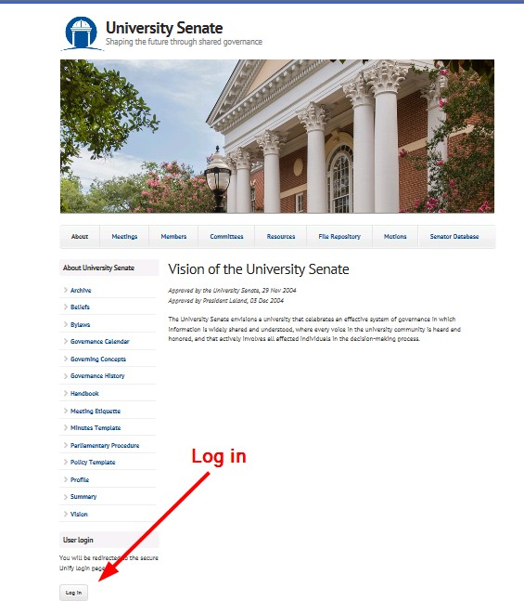

### Accessing and Utilizing the Motion Database

#### Access Motion Database

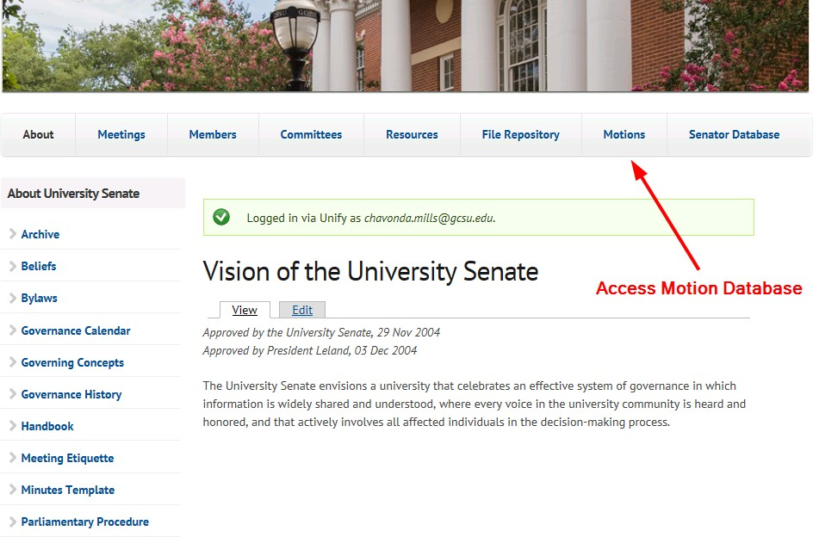

#### Add New Motion

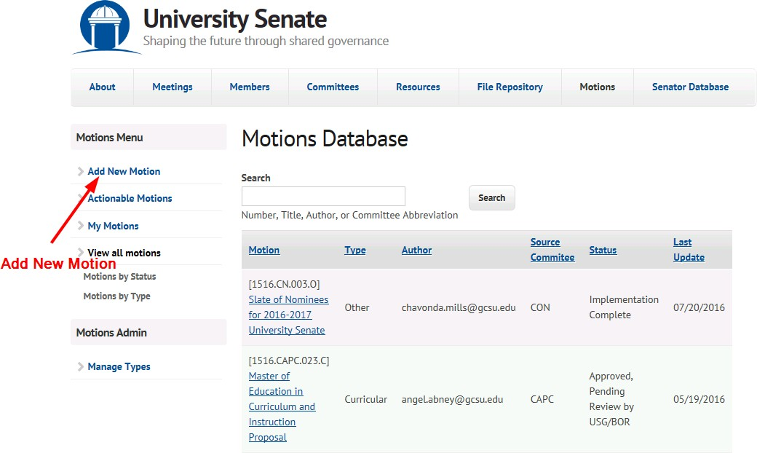

#### Complete Motion Entry Form and Save

### Accessing and Submitting Meeting Agenda through the File Repository

#### Access File Repository

#### Select File Type, Public or Private

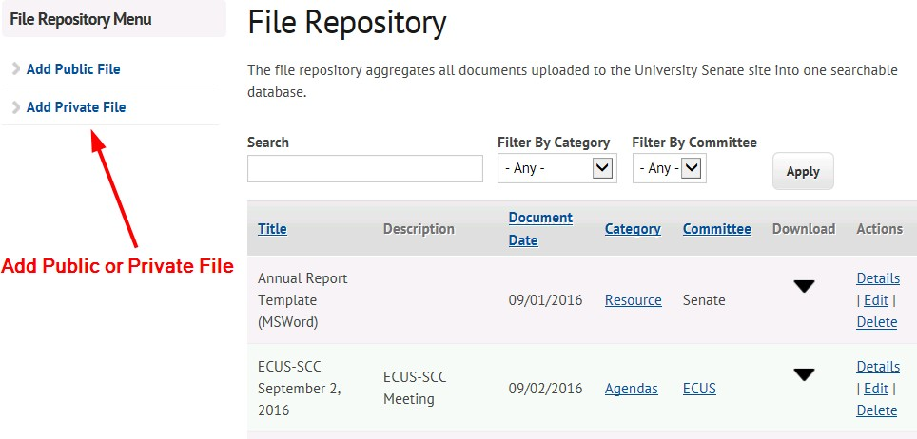

#### Complete Create Document Form and Save

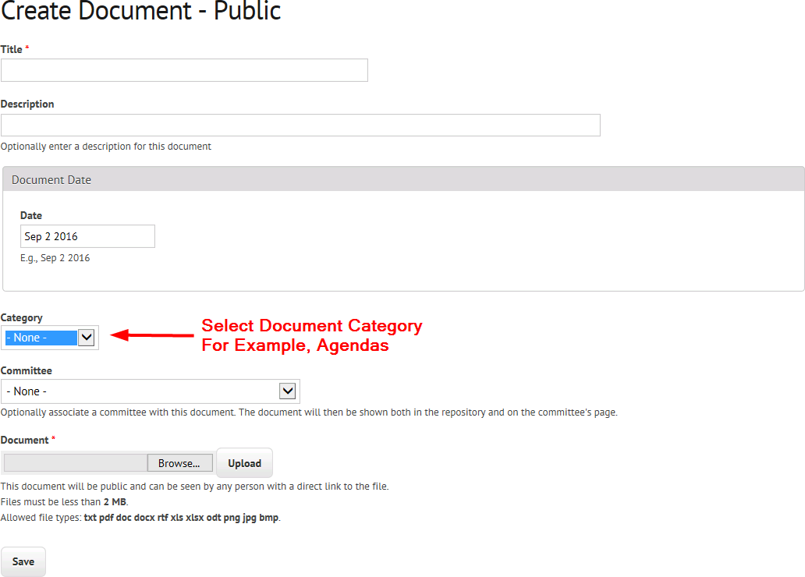

### Submission of Minutes

#### [Minutes Template](https://senate.gcsu.edu/sites/default/files/public-repository/MinutesTemplate_0.docx)

#### Add Minutes

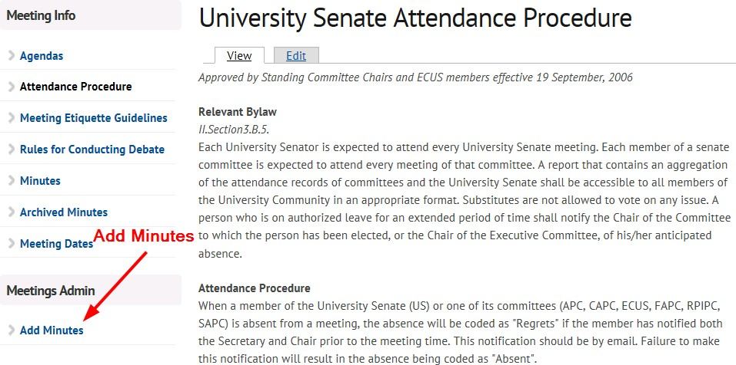

#### Complete Meeting Record with Minutes Form

