2024 Standing Committee Officer Training

Table of Contents

Meeting Schedule 2

2024-25 **University Senate**, Standing Committee, and *ECUS with* *Standing Committee Chairs Meetings* 2

2025-2026 **University Senate** Organizational Meeting 2

Highlights from 2023-24 and Items on the Horizon in 2024-25 2

Academic Policy Committee (APC) 2

Diversity, Equity, and Inclusion Policy Committee (DEIPC) 3

Executive Committee of the University Senate (ECUS) 3

Faculty Affairs Policy Committee (FAPC) 4

Resources, Planning, and Institutional Policy Committee (RPIPC) 5

Student Affairs Policy Committee (SAPC) 6

Sub-Committee on Nominations (SCoN) 6

Standing Committee Officer Training (elected officers of senate committees) 7

Standing Committee Officer Responsibilities 7

Standing Committee Chairs 7

Standing Committee Vice-Chairs 7

Standing Committee Secretaries 7

Responsibilities to be Assigned or Defined by the Committee 8

Pertinent University Senate Bylaws 8

Ongoing Committee Reminders 8

Standing Committee Scopes 9

Required Written Reports 9

Committee Chair to University Senate 9

Committee Annual Report 9

Standing Committee Chairs with Executive Committee 10

Purposes of Motions 10

University Senate Website Navigation 11

University Senate Management System: Log in with UNIFY username and password 11

Accessing and Utilizing the Motion Database 12

Accessing and Submitting Meeting Agenda through the File Repository 14

Submission of Minutes 16

# Meeting Schedule

## 2024-25 **University Senate**, Standing Committee, and *ECUS with* *Standing Committee Chairs Meetings*

* Friday 6 Sep 2024 2:00-3:15pm Standing Committees: APC, DEIPC, ECUS, FAPC, RPIPC, SAPC
* Friday 6 Sep 2024 3:30-4:45pm Parks 301: *ECUS with Standing Committee Chairs*
* Friday 20 Sep 2024 3:30-4:45pm Arts & Sciences 272: **University Senate**
* Friday 4 Oct 2024 2:00-3:15pm Standing Committees: APC, DEIPC, ECUS, FAPC, RPIPC, SAPC
* Friday 4 Oct 2024 3:30-4:45pm Parks Hall 301: *ECUS with Standing Committee Chairs*
* Friday 18 Oct 2024 3:30-4:45pm Arts & Sciences 272: **University Senate**
* Friday 1 Nov 2024 2:00-3:15pm Standing Committees: APC, DEIPC, ECUS, FAPC, RPIPC, SAPC
* Friday 1 Nov 2024 3:30-4:45pm Parks Hall 301: *ECUS with Standing Committee Chairs*
* Friday 15 Nov 2024 3:30-4:45pm Arts & Sciences 272: **University Senate**
* Friday 10 Jan 2025 2:00-3:15pm Standing Committees: APC, DEIPC, ECUS, FAPC, RPIPC, SAPC
* Friday 10 Jan 2025 3:30-4:45pm Online: *ECUS with Standing Committee Chairs*
* Friday 24 Jan 2025 3:30-4:45pm Arts & Sciences 272: **University Senate**
* Friday 14 Feb 2025 2:00-3:15pm Standing Committees: APC, DEIPC, ECUS, FAPC, RPIPC, SAPC
* Friday 14 Feb 2025 3:30-4:45pm Parks Hall 301: *ECUS with Standing Committee Chairs*
* Friday 28 Feb 2025 3:30-4:45pm Arts & Sciences 272: **University Senate**
* Friday 7 Mar 2025 2:00-3:15pm Standing Committees: APC, DEIPC, ECUS, FAPC, RPIPC, SAPC
* Friday 7 Mar 2025 3:30-3:15pm Parks Hall 301: *ECUS with Standing Committee Chairs*
* Friday 28 Mar 2025 3:30-4:45pm Arts & Sciences 272: **University Senate**
* Friday 4 Apr 2025 2:00-3:15pm Standing Committees: APC, DEIPC, ECUS, FAPC, RPIPC, SAPC
* Friday 4 Apr 2025 3:30-4:45pm Parks Hall 301: *ECUS with Standing Committee Chairs*
* Friday 25 Apr 2025 2:00-3:15pm Arts & Sciences 272: **University Senate** (NOTE: 2 pm meeting time)

## 2025-2026 **University Senate** Organizational Meeting

* Friday 25 Apr 2025 3:30-4:45pm Arts & Sciences 272: **University Senate** Organizational Meeting, including Standing Committee Organizational Meetings

# Highlights from 2023-24 and Items on the Horizon in 2024-25

## [Academic Policy Committee (APC)](https://senate.gcsu.edu/committee/apc)

* Academic Integrity Implications of Artificial Intelligence: The committee, at the request of faculty, considered a change in GCSU’s academic dishonesty policy to ensure that the inappropriate use of AI technologies was clearly forbidden. The committee investigated all pertinent policies at other USG institutions to determine what language sister universities and colleges may already have in place. The committee found that only Augusta University and the University of Georgia had so far altered their policies to reflect the new landscape. Faculty members Joy Bracewell and Cynthia Alby were consulted for their experience and expertise. The committee ultimately found that the GCSU academic dishonesty policy’s current language regarding plagiarism needed updating, which led to the proposal of motion 2324.APC.001.P, found below.
* Overload Policy: Some faculty in the APC reported concern with the lack of a policy to determine adequate and equitable overload pay for members of the Corps of Instruction. The chair of the APC was requested to broach this topic with ECUS and the FPAC committee following the September 1, 2023 APC meeting. No further action was taken by the APC.
* Final Examination Policy: At the request of FAPC, APC was asked to consider a revision to the Final Exam Policy. APC considered the matter in its meeting of October 6, 2023, and chose not to consider a change of policy at that time.
* Core Curriculum Updates: At the request of the General Education Committee, the Academic Policy Committee advanced a motion to the University Senate (2324.APC.002.P, found below) to add language regarding the new University System of Georgia-mandated Core Impacts policy to the existing GCSU Required Syllabus Statements policy.
* Syllabus Statement on Diversity, Equity, and Inclusion: At the request of DEIPC, the Academic Policy Committee reviewed the proposed suggested syllabus statement on Diversity, Equity, and Inclusion. The Academic Policy Committee did not feel that it was in our purview to co-sponsor the proposed suggested syllabus statement, but we felt that its language was appropriate, so long as it was included on a separate webpage for suggested syllabus statements, rather than the page for required syllabus statements.

## [Diversity, Equity, and Inclusion Policy Committee (DEIPC)](https://senate.gcsu.edu/committee/deipc)

## [Executive Committee of the University Senate (ECUS)](https://senate.gcsu.edu/committee/ecus)

* Following the resignation of Presiding Officer-Elect/SCoN Chair Catherine Fowler effective at the end of the February 23, 2024 meeting, SCoN duties were collaboratively shared by Presiding Officer Rob Sumowski, Secretary Alex Blazer, and Past Presiding Officer Jennifer Flory.
* ECUS drafted a By-laws revision motion creating a process for replacing the Presiding Officer-Elect and/or Secretary during the academic year should a vacancy arise.
* The By-laws revision (2324.ECUS.001.B) was read at the March 15 Senate meeting and approved by both the Senate and President Cox at the 2 pm meeting on April 26, 2024.
* At its April 5, 2024 meeting ECUS changed USGFC representation on the University System of Georgia Faculty Council to allow for continuity and better institutional representation at the USG level. Beginning with the 2024-2025 School Year, GCSU’s University Senate Representatives on USGFC will be 2 Elected Faculty Senators (appointed by SCoN); one voting member and one nonvoting member that will represent GCSU in the absence of the voting member. The representatives will serve a term of 3 years with the possibility of renewal regardless of status as EFS at the conclusion of the 3year term.
* Consecutive Meetings: Having ECUS and ECUS/SCC meet consecutively at 2:00 (amended in September 2023 to 2:45 pm to conserve time) and 3:30 respectively continues to work well. The PO should continue to be conscientious about which agenda topics are for ECUS and which are for ECUS/SCC. The POE report and the SCoN report often overlap as the POE chairs SCoN.
* Electronic Presence of the University Senate – continue test-driving, consider publishing governance calendar to 25Live
* University Senate Budget and Foundation accounts (how they are used)
* Continue how best to receive updates from university senate representatives on task forces and committees.
* Consider how much detail is necessary in standing committee chair reports to ECUS-SCC, highlights or details? Important that these reports are archived in electronic minutes including information items.
* Review current practices of and recommend best practices for the maintenance of the Policies, Procedures and Practices Manual, specifically regarding, first, the creation of an annually released pdf version of the manual and, second, incorporating notations regarding who, when, and why updates to the manual are made.

## [Faculty Affairs Policy Committee (FAPC)](https://senate.gcsu.edu/committee/fapc)

* FAPC worked with ECUS and the Provost’s Office to modify the current SRIS and IFR policy regarding SRIS to include all courses taught by instructors instead of only two. We introduced motions that were approved by University Senate (US) on these items in February 2024. These policies brought us into alignment with the policies and procedures used by other USG institutions as well as emphasized the importance of soliciting feedback from student voices in evaluating instructional quality. However, it was heavily discussed that the limitations of using student evaluations as the sole measure of teaching effectiveness be communicated with chairs and others in supervisory positions and, with the endorsement of the Provost, a communication strategy will be put into place instructing chairs/supervisors on the relevant existing policies on how to measure teaching effectiveness using additional measures outside of SRIS.
* FAPC discussed the Emeritus Policy alongside ECUS and the Office of the Provost. In a version of the current policy recorded solely in the Senate database, a grandfather clause existed allowing applicants to circumvent their home department and appeal straight to the Provost’s office if they wished to apply for Emeritus Status outside of the set policy timeline of 30 days prior to retirement date or 30 days into the following academic term following retirement. However, upon review of the policy as available to the public in the manual online, that clause does not exist, therefore is not a concern, though, if it should appear again, FAPC agreed that all applications should start in the applicant’s home department.
  + FAPC did, however, disagree with the arbitrary timeline established in the current policy, arguing, instead, that it should be left to the home department to determine if an applicant has met the high standards for being granted Emeritus Status and moving the applications up through the chain of command.
* FAPC worked with RPIPC on the Amorous Relationship Policy implementation and interpretation. We encountered many stumbling blocks in our endeavors to work on this policy with HR, but thoroughly reviewed the policy as recorded in the policy manual as a committee. We concluded that it reflects the “prohibits” wording of the USG policy and outlines ways to report violations (either self-report or by General Complaint Form), therefore, the policy as written could be left intact as long as HR believes it is sufficient.
* FAPC also passed along two informational items after thorough review to the US on behalf of the Office of the Provost. o The changes to the PTR policy regarding the appeals process faculty have in the case of an unfavorable PTR as well as an unfavorable PIP review were made by the USG and reviewed by FAPC before being instated as policy. o FAPC reviewed the modifications to the Research Misconduct Policy as requested by ECUS and the Office of the Provost and found no concerns and had no comments.
* Emeritus Status Policy o FAPC drafted changes to the policy to reflect the changes to the timeline. Please review said policy as a committee and, if all agree, move to get that policy into a motion for as early as possible in the next academic year, please.
* Extension of our work with SRIS and IFRs: the existing policy on using more than SRIS to measure teaching effectiveness o FAPC should work with CTL to create a link in the policy manual linked above to a list of viable, effective methods of evaluation of teaching effectiveness that is housed on the CTL website (as to avoid needing to revise policy in order to modify the list) so that faculty and supervisors can work together to find the best fit for them.
* Though this will be challenging, I would encourage FAPC to work with Dr. Roberts’ office to assist with data collection to determine salary ranges of adjunct faculty by college and department as well as looking into possible inequitable compensation for program coordinators/admin duties across the colleges and departments.
* The Policies, Procedures and Practices Manual (PPPM) needs to be thoroughly reviewed and more transparency should exist regarding who has access to the manual and who is responsible for making changes to the policies in the PPPM.
  + It was clear from the Emeritus Status Policy that changes made in the US consistently reflected in the PPPM and that changes are made the PPPM without US’s knowledge. It’s vital that faculty and staff are able to be kept informed regarding policies and procedures that directly impact them and that the PPPM that is publicly available reflects the most up-to-date policies and procedures passed by US to avoid confusion.

## [Resources, Planning, and Institutional Policy Committee (RPIPC)](https://senate.gcsu.edu/committee/rpipc)

* GCSU Amorous Relationship Policy Reporting Procedures - RPIPC took on this item from the previous year’s agenda. This item was addressed in tandem with FAPC. Our task was to develop a reporting procedure that would ensure that the Amorous Relationship policy was strictly followed. We started with a draft of procedures that was created in the previous year. We had the then GCSU General Counsel, Brent Montroy, review the procedure. Brent made modifications and advised on specifics of the procedures. Based on his counsel, we reached out to GCSU’s Chief Human Resources Officer, Carol Ward, for clarification on how married spouses would be handled in specific situations based on USG policy. While waiting to hear back from Carol, the chair of FAPC found existing procedures embedded in GCSU Amorous Relationship Policy that we believe to be sufficient. We are waiting for agreement from HR but believe the matter is resolved.
* Parking - Members of RPIPC brought concerns from their peers that students were parking in employee lots. It was believed that the move from hang tags to license plates for parking identification led to some confusion for students about which lots they could park in. John Jackson, the Director of Parking & Transportation Services and a member of RPIPC, presented the committee with information on parking fines for the first several weeks of the school year. Parking & Transportation put up signs to indicate faculty lots. This seemed to resolve the issue.
* The committee also addressed complaints about the student pickup system in the Kilpatrick Hall parking lot for Early College. Early College students’ parents were backed up to the point of blocking the ability for people to enter and exit the Peabody parking lot. Parking & Transportation with the help of Public Safety put up signs directing Early College parents not to block the Peabody lot.
* Summer Utility Costs - The committee invited Frank Baugh, the Assistant Vice President for Facilities, to present information about summer utility costs. Based on his information, the committee spent part of the year developing ideas for potentially reducing summer utility costs. The committee came up with two items to pursue. The first item was to work with Frank to have a campus-wide utility audit conducted. Frank agreed to move forward with an audit but did not feel that it could be accomplished in the near term based on his present staffing. The committee agreed to pass the item to next year’s RPIPC committee. The second item was to have a checklist created for all building managers to use to shutdown faculty offices and workspaces for all faculty that are not planning to be on campus during the summer. The committee approached the Sustainability Council about developing the checklist and dispersing it to building managers. The Sustainability Council agreed to take on the task.
* We recommend that nest year’s committee start with two items. The first item is to continue the partnership with Facilities to have a campus-wide energy audit conducted. The second item was suggested by ECUS. This item would be to address the lack of auditing capabilities for GCSU’s policy storage. There is currently no system to record when policies are changed, what was changed, and who changed them.

## [Student Affairs Policy Committee (SAPC)](https://senate.gcsu.edu/committee/sapc)

* In the 2024-2024 academic year, the Student Affairs Policy Committee discussed and considered a DEIPC request of the student committee review of recommended syllabus diversity statement. This was unanimously approved by both student representatives and faculty committee members. The committee also discussed and considered various safety concerns brought by student representatives following the IACLIA Safety Company audit of campus. Suggestions were to stress the safety app Rave Guardian, self-defense classes, de-escalation classes, and campus safety walks. Students reported they do not feel unsafe but disconnected from Safety as they do not see them on campus.
  + Follow-up with Chief Hardin noted all student concerns were addressed but experienced that there was difficulty with student participation in the requested programs. Student representatives reported back to student government to encourage participation in safety programs.
* For the 2024-2024 academic year, it is important that SAPC continues to work closely with members of the student government. Specifically, the committee needs regular student speakers at the meetings so we can properly address issues and concerns within the student body. It is recommended that SGA designate alternate speakers to attend SAPC meetings should the student SAPC members be otherwise engaged.

## Sub-Committee on Nominations (SCoN)

* The SCoN drafted multiple motions for the revised slate of nominees for university senate officers (Secretary, Presiding Officer) and university senate committee members (APC, ECUS, FAPC, RPIPC, SAPC, DEIPC) for review and vote at the following meetings:
  + Friday 15 Sep 2023, 3:30p–4:45p (University Senate)
  + Friday 19 Jan 2024, 3:30p–4:45p (University Senate)
  + Friday 26 April 2024, 2:00p–3:15p (University Senate)
* At the Friday 26 Apr 2024 2:00p–3:15p 2023–2024 University Senate meeting, the SCoN held an election to replace the Presiding Officer Elect for the 2023–2024 University Senate. Nicholas Creel was elected unopposed. Then, officer elections were held for the 2024–2025 University Senate. There were no nominations from the floor. Stephanie Jett and Alex Blazer were elected unopposed as Presiding Officer Elect and Secretary respectively.
* For review and vote at the Friday 26 Apr 2024 3:30p–4:45p 2024–2025 Organizational Meeting, the SCoN drafted a motion for the slate of nominees for university senate officers (Secretary, Presiding Officer Elect), university senate committee members (APC, ECUS, FAPC, RPIPC, SAPC, DEIPC), and individuals who will serve as university senate representatives on university committees external to the university senate during the 2024–2025 academic year.
* It is recommended that committee information, representation, etc. be reviewed and updated in spring 2025.
* It is recommended that the Committee Officer Elections and Orientation take place during the senate retreat for any standing committees who did not have a quorum at the organizational meeting in April.

# Standing Committee Officer Training (elected officers of senate committees)

## Standing Committee Officer Responsibilities

### Standing Committee Chairs

* + - Eligibility: Elected Faculty Senators who are members of the standing committee
    - Post standing committee meeting agendas to the Senate website. Email the [US secretary](mailto:alex.blazer@gcsu.edu) written reports after ECUS-SCC and University Senate meetings.
    - Bylaws Responsibilities:
      * + Present Committee Report to University Senate at scheduled University Senate meetings (Article II, Sec 3.A.3)
        + Submit such reports to University Senate Secretary in appropriate format for minutes (Article II Section 3.I)
        + Transfer committee records to the following year's committee (Article IV, Sec 3.B)
        + Meet regularly with the Executive Committee and other chairs to facilitate communication (Article V, Sec 1.C.14)
        + Serve on the Subcommittee on Nominations (Article V, Sec 1.D.1.a)
        + Be notified by a committee member who is going on extended leave (Article II Section 3.H)
        + Be consulted by ECUS on due date and format of comprehensive annual report of committee (Article IV, Sec 2)
        + Be consulted by ECUS on steering any matter to a standing committee (Article V, Sec 1.C.4)
    - Other Responsibilities:
      * + Be contacted by committee members extending regrets prior to the meeting
        + Others as defined by the committee

### Standing Committee Vice-Chairs

* Eligibility: Any member of the standing committee
* Bylaws Responsibilities: None
* Other Responsibilities:
* Assumes all duties and responsibilities of the Committee Chair in the absence of the Committee Chair
* To be defined by the committee

### Standing Committee Secretaries

* Eligibility: Any member of the standing committee
* Post standing committee meeting minutes to the Senate website.
* Bylaws Responsibilities: The secretary of the committee shall post the minutes of a committee meeting prior to the call to order of the next meeting of the committee. This includes minutes of any subcommittee or ad hoc committee that reports to it. (Article V, Section 2.B.3)
* Other Responsibilities:
* Be contacted by committee members extending regrets prior to the meeting
* To be defined by the committee

## Responsibilities to be Assigned or Defined by the Committee

* Chairs or secretaries, please email the [US secretary](mailto:alex.blazer@gcsu.edu) approved operating procedures and he will post them to the Senate website
* When a vacancy on the committee occurs, a replacement determined in same manner
* Scheduling meeting rooms, times, and dates for committee meetings
* Conducting meetings (preside at meetings)
* Conducting forums
* Supplying an agenda for committee meetings with electronic documentation
* **Establishing operating policies/procedures and filing with ECUS**
* Writing and submitting a comprehensive, written annual report
* Entering motions in the online motion database to get a motion on the floor of Senate
* Ad hoc committee registry form submission
* Advertising Meeting Times and Agenda to the University Community
* Promoting the Governing Concepts of the University Senate in order to increase the university community’s capacity for shared governance

## Pertinent University Senate Bylaws

* IV.Section3.A. Organizational Meetings. Within ten (10) calendar days of the spring organizational meeting of the incoming University Senate for the subsequent academic year, each of the incoming standing committees shall hold a meeting at which they elect committee officers in accordance with V.Section2.B.1. The Executive Committee shall designate a facilitator to both preside at this meeting and conduct the elections of the committee officers. Should there be any unfilled positions on the incoming committee, specifically members not known by name such as SGA appointees, Presidential Appointees named by title, etc., the Executive Committee shall name voting proxies for the elections of the committee officers from the pool of outgoing committee members.
* V.Section2.B.1. Officers. The members of a standing committee shall elect a chair, a vice-chair, and a secretary by secret ballot in accordance with IV.Section3.A. Only elected faculty senators are eligible to serve as the committee chair, but any member of the committee is eligible to serve as vice-chair or secretary. The chair, vice-chair, and secretary shall be elected for a period of one year. The chair, vice-chair, or the secretary may be reelected.

## Ongoing Committee Reminders

* Options for **working groups**
  + subcommittees (requires bylaws change),
  + ad hoc committee (formal – Bylaws V.Section2.A.3.b. requires a charter in consultation ECUS)
  + information gathering group (informal)
* Be intentional on **sharing information with the entire University Community**. This might include the identification of particular committee members to share information with students, staff, faculty, administration.
* **Copy monthly committee meeting agenda** to standing committee chairs executive committee when distributing it to committee members to keep all in the information loop.
* **Upload monthly committee meeting agenda** to Senate website.
* At the end of each monthly meeting, consider having the secretary summarize the meeting (this allows committee members to clarify the draft minutes while the meeting is still “fresh” in their minds).
* At the end of each monthly meeting, consider setting tentative agenda of the following meeting.
* Consider **overflow meeting time** when drafting/revising committee operating procedures.

FYI: From 11-21-06 ECUS meeting: Suggested that for both the larger group and Standing Committees that when motions are made that someone other than the presiding officer (such as the Administrative Assistant or Past Presiding Officer) track and display in a prominent way the motion statement in the meeting room reflecting any amendments to a motion so that Senators or committee members are able to see the exact motion statements including amendments made from the floor during debate and when they vote on the motions.

## Standing Committee Scopes

* V.Section2.C.1.b. *Scope*. The **Academic Policy Committee** shall review and recommend for or against policy relating to undergraduate and graduate education matters that have broad impact or implication to the university as a whole, which includes, but is not limited to, policies relating to grading, scholastic probation and honors, academic appeals, academic standing, standards for admission, academic calendar, and academic ceremonies. This committee also provides advice, as appropriate, on academic procedural matters at the institution.
* V.Section2.C.2.b. *Scope*. The **Diversity, Equity, and Inclusion Policy Committee** shall review and recommend for or against policy related to inclusion, equity, and diversity, which includes, but is not limited to, policies relating to all institutional aspects of equitable access, success, and education of the university community on issues of diversity, inclusion, state and federal laws regarding protected classes, and university language relating to non-discrimination and diversity. In addition, this committee shall review and provide advice on procedures, guidelines, and employee and student professional development relating to institutional climate and priorities for ensuring justice, fairness, and equitable treatment to all members of the university.
* V.Section2.C.3.b. *Scope*. The **Faculty Affairs Policy Committee** shall review and recommend for or against policy relating to faculty welfare (e.g. authorities, responsibilities, rights, recognitions, privileges, and opportunities), which includes, but is not limited to, policies relating to academic freedom, workload, compensation, recruitment, retention, promotion, tenure, recognitions, development, and instructional support. This committee also provides advice, as appropriate, on procedural matters that affect the welfare of the faculty.
* V.Section2.C.4.b. *Scope*. The **Student Affairs Policy Committee** shall review and recommend for or against policy relating to the general social, cultural, and practical welfare of students, which includes, but is not limited to, policies relating to non-academic areas such as conduct and discipline, grievances and non-academic appeals, financial aid, human services for students (e.g. health center, counseling), organizations, awards, intercollegiate athletics, and other extracurricular activities (e.g. Greek life, residence life, intramurals). This committee also provides advice, as appropriate, on procedural matters that affect the general social, cultural, and practical welfare of the students.
* V.Section2.C.5.b. *Scope*. The **Resources, Planning, and Institutional Policy Committee** shall review and recommend for or against policy relating to non-instructional personnel (including administrative personnel) and institutional budget and planning functions, which includes, but is not limited to, policies relating to recruitment, hiring, evaluation, welfare and development as well as compliance with local, state, and federal guidelines (e.g. affirmative action, ADA, homeland security), and institutional support functions of the university (e.g. technology, parking) In addition, this committee shall review and provide advice on master planning, strategic planning, and budgeting processes and provides advice, as appropriate, on other procedural matters that affect the general welfare of the institution and its employees.

## Required Written Reports

### Committee Chair to University Senate

* II.Section3.A.3. *Reports.* Each standing committee and the Executive Committee, through its duly elected chair, shall, at all regular meetings of the University Senate, make a brief oral report of business transacted by the committee since the previous meeting of the University Senate. In addition, II.Section3.I. applies to such reports.
* II.Section3.I. *Reports.* All reports given at a University Senate meeting shall be submitted in an appropriate format to the Secretary of the University Senate for inclusion in the minutes of that meeting.
* [Minutes Template](https://senate.gcsu.edu/us/about-university-senate/minutes-template)

### Committee Annual Report

* + - IV.Section 2. *Reports*. The committees listed in V.Section2.A.1 shall constitute the standing committees of the University Senate. Each standing committee and the Executive Committee shall present a comprehensive, written, annual report in an appropriate format to the Executive Committee. This report shall include a summary of the major items considered by the committee during the academic year and the disposition of each. The Executive Committee shall set a due date and the format of these reports in consultation with the standing committee chairs and these reports shall be posted with the minutes of the last University Senate meeting of the academic year.
    - [Annual Report Template](https://senate.gcsu.edu/sites/default/files/public-repository/AR_Template.docx)
    - [Annual Reports Archive](https://us.gcsu.edu/Annual_Reports/index.htm)

### Standing Committee Chairs with Executive Committee

* V.Section1.C.14. Standing Committee Chairs Coordination. The Executive Committee shall meet regularly with the Standing Committee Chairs to facilitate communication among the committees of the University Senate.
* In practice, at the joint meetings of the Standing Committee Chairs with Executive Committee, each standing committee chair provides a brief oral report. While not formally required by bylaws, submitting those reports electronically (email or MSWord format) to ECUS secretary is desirable (to the ECUS Secretary).

## Purposes of Motions

* To RECOMMEND revisions to an existing policy
* To RECOMMEND revisions to existing University Senate Bylaws
* To ENDORSE procedural recommendations (more of a resolution than a motion; outside purview)
* To ENDORSE a resolution
* To RECOMMEND a new policy:
* [Policy Template](https://nam11.safelinks.protection.outlook.com/?url=https%3A%2F%2Fsenate.gcsu.edu%2Fus%2Fabout-university-senate%2Fpolicy-template&data=05%7C01%7Crobert.sumowski%40gcsu.edu%7C4dae2c039244497046e508db98578c5a%7Cbfd29cfa8e7142e69abc953a6d6f07d6%7C0%7C0%7C638271274377021329%7CUnknown%7CTWFpbGZsb3d8eyJWIjoiMC4wLjAwMDAiLCJQIjoiV2luMzIiLCJBTiI6Ik1haWwiLCJXVCI6Mn0%3D%7C3000%7C%7C%7C&sdata=u03TiP0v0rqELO1dB8Wf6yZ3tyr3FpJpEQrI3D3Xcac%3D&reserved=0)



## [University Senate Website](https://senate.gcsu.edu/)) Navigation

### University Senate Management System: Log in with UNIFY username and password

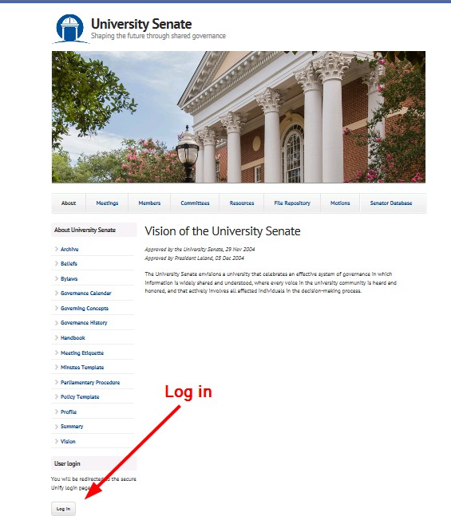

### Accessing and Utilizing the Motion Database

#### Access Motion Database

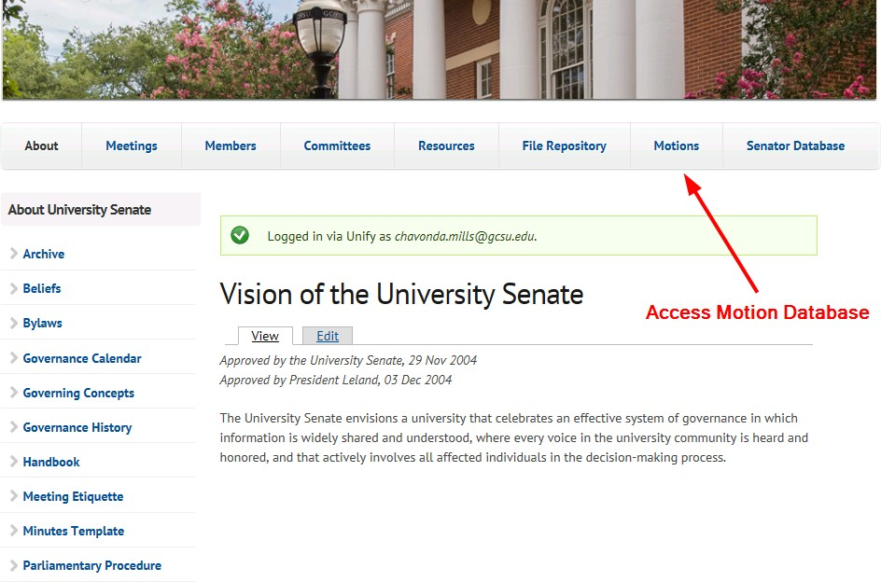

#### Add New Motion

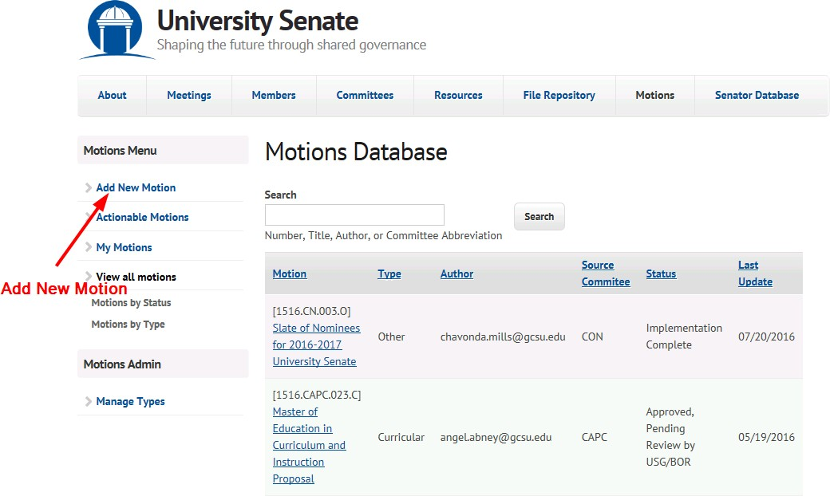

#### Complete Motion Entry Form and Save

### Accessing and Submitting Meeting Agenda through the File Repository

#### Access File Repository

#### Select File Type, Public or Private

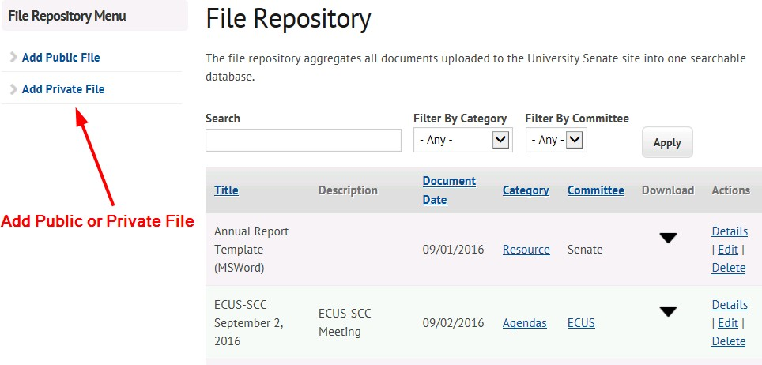

#### Complete Create Document Form and Save

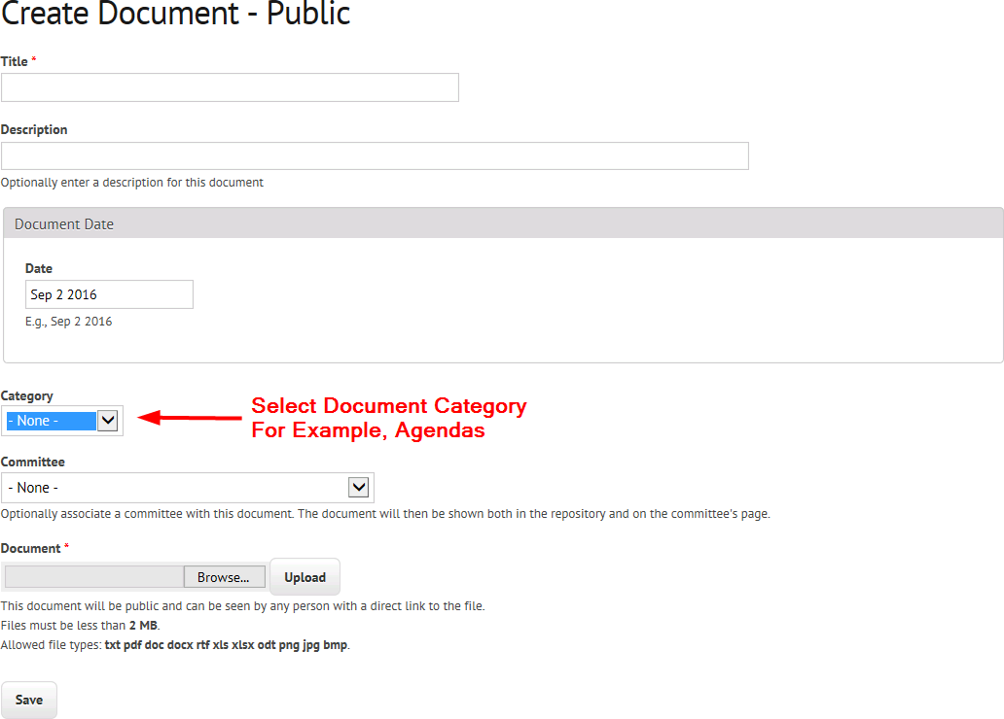

### Submission of Minutes

#### [Minutes Template](https://senate.gcsu.edu/sites/default/files/public-repository/MinutesTemplate_0.docx)

#### Add Minutes

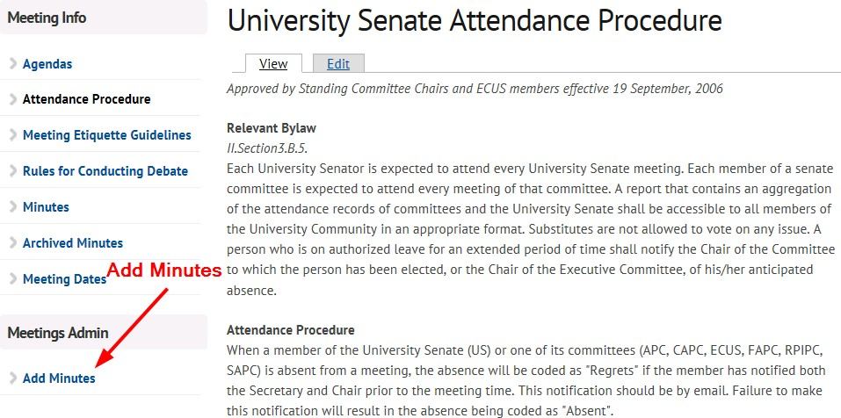

#### Complete Meeting Record with Minutes Form

