2022 University Senate Governance Retreat
Monday 08 August 2022
First United Methodist Church, 366 Log Cabin Rd NE, Milledgeville
Table of Contents
Agenda 3
Governance Retreat Planning Committee 3
Standing Committee Meetings (10:45 am) 4
Tasks 4
2022-2023 University Senate Standing Committees 4
Concurrent Sessions (11:15 am) 5
Orientation to University Senate 5
2022-23 University Senate, Standing Committee, and ECUS with Standing Committee Chairs Meetings 5
2023-24 University Senate Organizational Meeting 5
WHO is on the University Senate? 5
WHAT does the University Senate do? 6
WHAT are the responsibilities and expectations of a University Senator? 6
WHEN did the University Senate begin? 6
WHAT is the committee structure of the University Senate? 6
WHAT are the primary responsibilities of the committees? 7
HOW can a member of the faculty serve on the University Senate or a University Senate committee? 7
With WHOM can I consult if I have specific questions? 8
University Senate website 8
Standing Committee Officer Training (elected officers of senate committees) 9
Standing Committee Officer Responsibilities 9
Standing Committee Scopes 11
Required Written Reports 12
Purposes of Motions 12
University Senate Website Navigation 13
Senate Goals, Moving Forward 19

University Senate Meeting Agenda 20
1. Call to Order – Jennifer Flory, Presiding Officer 20
2. Consent Agenda – Jennifer Flory 20
3. Old Business 20
4. New Business 20
5. President’s Report – President Cox 20
6. Provost’s Report – Provost Spirou 20
7. Standing Committee Reports 20
8. Announcements/Information Items 20
9. Open Discussion 20
10. Adjournment 20

Agenda
Time | Event | Location | Presenters/Facilitators
8:45 | Registration and Breakfast | Narthex | Blackbird Coffee,  Kroger Catering
9:00 | Welcome and Introductions | Sanctuary | Jennifer Flory,  Presiding Officer
9:05 | Greeting and University Updates | Sanctuary | President Cox
9:25 | Academic Affairs Updates | Sanctuary | Provost Costas Spirou
9:45 | Budget and Finance Updates | Sanctuary | Vice President Lee Frutticher
10:05 | Strategic Planning Steering Committee Updates | Sanctuary | Holley Roberts,  Associate Provost, Co-Chair  Diana Young,  US Representative, Co-Chair
10:25 | New Senator Recognition  (pins) | Sanctuary | Jennifer Flory,  Presiding Officer
10:30 | Welcome Volunteers and Appointees, break,  and move to Committee Breakout Rooms |  | Jennifer Flory,  Presiding Officer
10:45 | Standing Committee Election of Officers and  Organizational Meetings (Senators, Appointees, Volunteers) |  | ECUS/SCC Members
 | APC | Room 2 (choir room) | Nicholas Creel
 | DEIPC | Room 5 | Lamonica Sanford
 | FAPC | Room 4 | Sabrina Hom, Chair  (Elected 4/22/22)
 | RPIPC | Room 1 | Rob Sumowski,  Presiding Officer Elect
 | SAPC | Room 8 | Catherine Fowler,  Past Presiding Officer
Concurrent Sessions
11:15 | Orientation to University Senate (new senators, appointees, volunteers, and anyone who would like a refresher) | Room 2 (choir room) | Rob Sumowski,  Presiding Officer Elect
11:15 | Standing Committee Officer Training (elected officers of senate committees) | Room 1 | Catherine Fowler,  Past Presiding Officer
11:15 | Senate Goals, Moving Forward (returning senators, appointees, volunteers) | Sanctuary | Jennifer Flory,  Presiding Officer
11:45 | Mock Senate Meeting  (separate agenda) | Sanctuary | Jennifer Flory,  Presiding Officer
12:00 | Adjournment and Lunch | Sanctuary | Stacked

Governance Retreat Planning Committee
Jennifer Flory, chair
Ashley Banks
Alex Blazer
Catherine Fowler
Rob Sumowski

Standing Committee Meetings (10:45 am)
Committee | Location | Facilitator
APC | Room 2 (choir room) | Nicholas Creel
DEIPC | Room 5 | Lamonica Sanford
FAPC | Room 4 | Sabrina Hom, Chair (elected 4/22/22)
RPIPC | Room 1 | Rob Sumowski, Presiding Officer Elect
SAPC | Room 8 | Catherine Fowler, Past Presiding Officer

Tasks
- Elect chair, vice-chair, and secretary (secretary will take notes that can later be archived)
- Set meeting place for standing committee meetings and file with Executive Committee.
- Review 2021-2022 standing committee annual report, in particular the recommendations.
- Identify potential new business.
- Establish Committee Operating Procedures for 2022-2023 senate term: last year’s operating procedures are in the annual report, and these may be adopted with minor revisions.
- Prepare a brief committee report on items 1-4 for the mock university senate meeting.

2022-2023 University Senate Standing Committees
ECUS | APC | DEIPC | FAPC | RPIPC | SAPC
Cox, Cathy  (President) | +Clark,  Benjamin | +Bradley,  Linda | +Edmondson,  Hank | +Cazacu,  Rodica | +Cross,  Paulette
Spirou, Costas  (Provost) | +Domingue,  Donovan | +Christensen,  Mikkel | +Hom,  Sabrina (chair) | +Evans,  Kerry James | +Glotzbecker,  Greg
Flory, Jennifer  (Presiding Officer) | +Muschell,  Lyndall | +Ling,  Leng | +Jett,  Stephanie | +Fowler,  Brad | +Godwin,  Gail
Sumowski, Rob  (Presiding Officer Elect) | +Myers,  Sarah | +Speelman,  Liz | +Milnes,  Matthew | +Francis,  Damian | +Pinney,  Amy
Blazer, Alex  (Secretary) | +Stoyanova,  Mariana | +Swan,  Jessamyn | +Park,  Jinkyung | Davis-Bray,  Nancy | Carpenter,  Kell
Sanford,  Lamonica | +Swinton,  John | +Trujillo,  Sandra | +Richardson,  Frank | Mizelle,  Nancy | Norris-Taylor,  Joyce
Creel,  Nicholas | +Whittle,  Benjamin | +Welborn,  Trae | +Rosado,  Peter | Banks,  Ashley | Congdon,  Kaitley
Fowler, Catherine  (Past Presiding Officer) | +Young,  Diana | Graham,  Jennifer | Croft,  Holly | Davis,  Matthew | Hilly,  Connor
 | Allen,  Andrew | Yearwood,  Jen | DeVore,  Melanie | Milam,  Lorraine | Blanch,  Kevin
 | Zoetewey,  David | Francisco,  Javier | Osobov,  Olha | Fruitticher,  Lee | Easom,  Lauren
 | Gorzelany-Mostak,  Dana | Murden,  Desaree | Clark,  Christopher | Kerr,  Susan | Eilers,  Ruth
 | Liles,  Alesa | Appointee,  SGA | Blumenthal,  Robert | Appointee,  SGA | Appointee,  SGA
 |  | Mayweather, Nadirah |  | Endere,  Josefina | Kang,  Rui
+Elected Faculty Senator: Only elected faculty senators are eligible to serve as the committee chair, but any member of the committee is eligible to serve as vice-chair or secretary.

Concurrent Sessions (11:15 am)
Session | Location | Facilitator
Orientation to University Senate (new senators, appointees, volunteers, and anyone who would like a refresher) | Room 2 (choir room) | Rob Sumowski,  Presiding Officer Elect
Standing Committee Officer Training (elected officers of senate committees) | Room 1 | Catherine Fowler,  Past Presiding Officer
Senate Goals, Moving Forward (returning senators, appointees, volunteers) | Sanctuary | Jennifer Flory,  Presiding Officer

Orientation to University Senate

2022-23 University Senate, Standing Committee, and ECUS with Standing Committee Chairs Meetings
- Friday 2 Sep 2022 2:00-3:15pm Standing Committees: APC, DEIPC, ECUS, FAPC, RPIPC, SAPC
- Friday 2 Sep 2022 3:30-4:45pm President’s Conference Room: ECUS with Standing Committee Chairs
- Friday 16 Sep 2022 3:30-4:45pm Arts & Sciences 272: University Senate
- Friday 7 Oct 2022 2:00-3:15pm Standing Committees: APC, DEIPC, ECUS, FAPC, RPIPC, SAPC
- Friday 7 Oct 2022 3:30-4:45pm President’s Conference Room: ECUS with Standing Committee Chairs
- Friday 21 Oct 2022 3:30-4:45pm Arts & Sciences 272: University Senate
- Friday 4 Nov 2022 2:00-3:15pm Standing Committees: APC, DEIPC, ECUS, FAPC, RPIPC, SAPC
- Friday 4 Nov 2022 3:30-4:45pm President’s Conference Room: ECUS with Standing Committee Chairs
- Friday 18 Nov 2022 3:30-4:45pm Arts & Sciences 272: University Senate
- Friday 6 Jan 2023 2:00-3:15pm Standing Committees: APC, DEIPC, ECUS, FAPC, RPIPC, SAPC
- Friday 6 Jan 2023 3:30-4:45pm President’s Conference Room: ECUS with Standing Committee Chairs
- Friday 20 Jan 2023 3:30-4:45pm Arts & Sciences 272: University Senate
- Friday 10 Feb 2023 2:00-3:15pm Standing Committees: APC, DEIPC, ECUS, FAPC, RPIPC, SAPC
- Friday 10 Feb 2023 3:30-4:45pm President’s Conference Room: ECUS with Standing Committee Chairs
- Friday 24 Feb 2023 3:30-4:45pm Arts & Sciences 272: University Senate
- Friday 3 Mar 2023 2:00-3:15pm Standing Committees: APC, DEIPC, ECUS, FAPC, RPIPC, SAPC
- Friday 3 Mar 2023 3:30-3:15pm President’s Conference Room: ECUS with Standing Committee Chairs
- Friday 24 Mar 2023 3:30-4:45pm Arts & Sciences 272: University Senate
- Friday 14 Apr 2023 2:00-3:15pm Standing Committees: APC, DEIPC, ECUS, FAPC, RPIPC, SAPC
- Friday 14 Apr 2023 3:30-4:45pm President’s Conference Room: ECUS with Standing Committee Chairs
- Friday 28 Apr 2023 2:00-3:15pm Arts & Sciences 272: University Senate (NOTE 2pm meeting time)

2023-24 University Senate Organizational Meeting
- Friday 28 Apr 2023 3:30-4:45pm Arts & Sciences 272: University Senate Organizational Meeting, including Standing Committee Organizational Meetings

WHO is on the University Senate?
The Members page provides the current membership roster of the University Senate while the Online Senator Database provides membership rosters of the university senate and its committees.
The University Senate is a faculty governance body consisting of fifty (50) members including the University President who serves as an ex-officio non-voting member, the Chief Academic Officer who serves as an ex officio non-voting member, thirty seven (37) elected faculty senators, four (4) staff members selected by Staff Council, two (2) student members selected by the Student Government Association, and four (5) members that are appointed by the University President. The University Senate elects one of its current elected faculty senator members to serve for a one year term as Presiding Officer.

WHAT does the University Senate do?
The University Senate is endowed with all the legislative powers and authority of the University Faculty by the institutional statutes, and exists to promote and implement effective shared governance at the university. It is expressly charged with recommending academic and institutional policy subject to the approval of the University President.
In addition to its policy recommending responsibility, the University Senate serves in an advisory role to the administration, particularly in the implementation of policy or improvement of processes that have broad institutional impact or implications, including but not limited to planning and budgetary processes. The University Senate strives to be mindful and respectful of matters that are more appropriately handled by the academic units (college, school, department, etc.) and divisions, yet may make recommendations concerning matters within these areas that have broader institutional impact or implications.

WHAT are the responsibilities and expectations of a University Senator?
- Responsibility to proactively seek out information and issues relevant to the standing committee on which you serve. (Article V Sec 2.B.2)
- Expectation to read information and supporting documents for motions PRIOR to the university senate meeting at which they will be considered. Note: This information is accessible via the online motion database.
- Expectation to prepare for committee meetings as defined by your committee operating procedure.
- Expectation to communicate with constituency, distribute information to and seek feedback from the individuals you represent.
- Right to speak, debate, and vote on the issues and motions that come before your committee or the University Senate.
- Request to gain familiarity with the University Senate web page at https://senate.gcsu.edu
- Request to extend “Regrets” to committee Chair and Secretary when anticipating absence from a meeting. Note: Failure to make this notification may result in the absence being coded as "Absent.”
- Who do I represent? (Constituency)
  - The thirty-seven Elected Faculty Senators (EFS) represent those who elected them.
  - The four Selected Staff Senators represent the staff.
  - The two Selected Student Senators by Student Government Association (SGA) represent the students.
  - The five Presidential Appointees and University President do not have a clearly defined constituency.
  - Ideally, all University Senators should work together to promote the best interest of the University.
- What meetings/functions am I expected to attend?
  - Annual Governance Retreat
  - Monthly University Senate meetings
  - Monthly committee meetings of which you are a member
- What committee(s) will I serve on?
  - Appointees (president, student, staff) and designees (executive officers) are named by the relevant constituencies. Elected faculty senators are invited to express preference for committee service following elections. The Subcommittee on Nominations prepares a slate of nominees for the committees based on those considerations. The slate is voted on each year at the organizational meeting of the University Senate.

WHEN did the University Senate begin?
A transition from a faculty senate to a university senate occurred between 2000 and 2002. While the faculty senate was populated exclusively by faculty, the university senate was designed with the intent of promoting a shared sense of purpose and collaboration among faculty, staff, students, and administrators. The ideals of shared information, transparent decision-making, and collegiality guide its continued development. The university senate also has an official Governance History found in the University Senate Handbook.

WHAT is the committee structure of the University Senate?
- The ACADEMIC POLICY COMMITTEE (APC) shall review and recommend for or against policy relating to undergraduate and graduate education matters that have broad impact or implication to the university as a whole.
- The DIVERSITY, EQUITY, and INCLUSION POLICY COMMITTEE (DEIPC) shall review and recommend for or against policy related to inclusion, equity, and diversity.
- The EXECUTIVE COMMITTEE OF THE UNIVERSITY SENATE (ECUS) is a faculty advisory body to both the University President and the Provost and serves as the Steering Committee of the University Senate.
- The FACULTY AFFAIRS POLICY COMMITTEE (FAPC) shall review and recommend for or against policy relating to faculty welfare (e.g. authorities, responsibilities, rights, recognitions, privileges, and opportunities).
- The RESOURCES, PLANNING, AND INSTITUTIONAL POLICY COMMITTEE (RPIPC) shall review and recommend for or against policy relating to non-instructional personnel (including administrative personnel) and institutional budget and planning functions.
- The STUDENT AFFAIRS POLICY COMMITTEE (SAPC) shall review and recommend for or against policy relating to the general social, cultural, and practical welfare of students.

WHAT are the primary responsibilities of the committees?
- Default – Disposition of US business through committees unless the US approves by two-thirds majority vote to act as a committee of the whole.
- Committee charge: seek out and identify concerns within its area
- Three Committee Functions
  - develop recommendations for new policy
  - develop recommendations that revise existing policy, and
  - serve in advisory role
- Two types of subcommittees
  - Permanent Subcommittee
    - Creation considered at request of committee, ECUS, or US
    - SCoN nominates membership including at least 2 University Senators
    - US elects voting membership & designates standing committee to which this permanent subcommittee reports
  - Ad hoc Committee (Temporary)
    - Creation at request of committee, ECUS, or US and this group shall name the membership including at least two Senators noting that all university community members are eligible to serve,
    - Charter (charge, timeline, membership) filed with ECUS
    - Chair (must be a University Senator), Vice-Chair, Secretary selected by the membership of the ad hoc committee at its first meeting
    - Ad hoc committees cease to exist at the completion of the task or at the end of academic year, whichever comes first.
  - Committee Report made by Chair at each University Senate Meeting (filed electronically)
  - Committee Business
    - Types: Policy, Information, Concern
    - Who can initiate
      - Any committee member
      - The Executive Committee (ECUS) in its steering function
      - Chief Academic Officer
      - University President
      - Written request to ECUS with at least three senator signatures
- Quorum – A majority of the membership (Robert’s Rules) (at least seven of the thirteen members)
- Who can vote at the committee meetings? All committee members including non-Senator members (those committee members not also on University Senate) are voting members of the committee unless explicitly designated as a non-voting member of the committee in the bylaws.

HOW can a member of the faculty serve on the University Senate or a University Senate committee?
The eligibility requirements to be nominated to serve as an Elected Faculty Senator are
- Membership in the Corps of Instruction, meaning full-time status at the rank of Professor, Associate Professor, Assistant Professor, Instructor, Senior Lecturer, or Lecturer, and
- The completion of at least two years of service at the university at the beginning of the fall semester following their election as an elected faculty senator.
In addition, there are Non-Senator positions on the standing committees available for Corps of Instruction faculty not presently serving on the University Senate.

With WHOM can I consult if I have specific questions?
- Committee Officers (Chair, Vice-Chair, Secretary)
- Executive Committee
- Other University Senators

University Senate website

University Senate Bylaws

University Senate Handbook

Mission
- Shaping the Future through Shared Governance

Vision
- The University Senate envisions a university that celebrates an effective system of governance in which information is widely shared and understood, where every voice in the university community is heard and honored, and that actively involves all affected individuals in the decision-making process.

Beliefs
- Faculty, staff, students and administrators will interact with mutual respect and will value input, rational discussion and respect for each person’s position or place at the University.
- All governance, planning, and decision making should encourage all interested and affected parties to be included.
- The existing rules, regulations, policies and procedures of Georgia College & State University should be clearly defined, supported, adhered to, and widely distributed among faculty, staff, students and administrators.
- Everyone shall have the right to participate in the governance of the University and shall have the right to be heard, without repercussion, regardless of position, rank, or level of authority.
- Faculty, staff, administrators and students share responsibility for the education and development of life-long learning opportunities at the University.
- Georgia College & State University will have a stable structure of governance that is flexible and includes a process for review and revision.

Governing Concepts
- The governing concepts of the University Senate listed below serve as ideals for shared governance and provide a means by which shared governance can be periodically assessed.
- Shared Sense of Purpose
- Collegial Leadership
- Transparent Decision Making
- Investment in Shared Governance
- Shared Information
- Positive Motivators
- Adequate Resources

Meeting Etiquette Guidelines

Operational Definitions
- Policy: A policy is a statement of record that governs the conduct of the university community and/or embodies a general principle that guides university affairs.
- Procedure: A procedure is a written statement intended to accompany a policy and promote its consistent implementation. Adherence to procedure is a means of standardizing policy implementation.
- Motion: A motion is a formal proposal, ideally expressed in writing, placed before an assembly for consideration, that, if adopted, advances to the next level.
- Resolution: A resolution is a body’s formal expression of a position, preference, will, or intention, made usually after voting, for distribution to person(s) external to the body.
- Concern: A concern is a matter that engages a person’s attention, interest, or care, or that affects a person’s welfare or happiness.
- Information Item: An information item is a statement or document that provides context or illuminates a point under consideration.
- Guideline: Guidelines suggest how policies should be accomplished and represent the recommended course of action. A guideline is a suggestion for the development or implementation of policy or procedure.
- Practice: A practice is a customary way of operating or behaving.
- Exhibit: An exhibit is a written statement presented for consideration, such as supporting documents or forms.

Proposal Submission Checklist

Policy Template

Motion Flow Checklist

Rules for Conducting Debate

Parliamentary Procedure

Robert's Rules Cheat Sheet

Governing History

Member Information
- Current University Senate Members
- University Senate Representatives
- University Senate Members Past and Present

University Senate Committees

Meeting Information
    - Governance Calendar
    - University Senate Attendance Procedure
    - Agendas
    - Meeting Minutes
    - Motions Database

Standing Committee Officer Training (elected officers of senate committees)

Standing Committee Officer Responsibilities

Standing Committee Chairs
    - Eligibility: Elected Faculty Senators who are members of the standing committee
    - Post standing committee meeting agendas to the Senate website. Email the US secretary written reports after ECUS-SCC and University Senate meetings.
    - Bylaws Responsibilities:
        - Present Committee Report to University Senate at scheduled University Senate meetings (Article II, Sec 3.A.3)
        - Submit such reports to University Senate Secretary in appropriate format for minutes (Article II Section 3.I)
        - Transfer committee records to the following year's committee (Article IV, Sec 3.B)
        - Meet regularly with the Executive Committee and other chairs to facilitate communication (Article V, Sec 1.C.14)
        - Serve on the Subcommittee on Nominations (Article V, Sec 1.D.1.a)
        - Be notified by a committee member who is going on extended leave (Article II Section 3.H)
        - Be consulted by ECUS on due date and format of comprehensive annual report of committee (Article IV, Sec 2)
        - Be consulted by ECUS on steering any matter to a standing committee (Article V, Sec 1.C.4)
    - Other Responsibilities:
        - Be contacted by committee members extending regrets prior to the meeting
        - Others as defined by the committee

Standing Committee Vice-Chairs
- Eligibility: Any member of the standing committee
- Bylaws Responsibilities: None
- Other Responsibilities:
- Assumes all duties and responsibilities of the Committee Chair in the absence of the Committee Chair
- To be defined by the committee

Standing Committee Secretaries
- Eligibility: Any member of the standing committee
- Post standing committee meeting minutes to the Senate website.
- Bylaws Responsibilities: The secretary of the committee shall post the minutes of a committee meeting prior to the call to order of the next meeting of the committee. This includes minutes of any subcommittee or ad hoc committee that reports to it. (Article V, Section 2.B.3)
- Other Responsibilities:
- Be contacted by committee members extending regrets prior to the meeting
- To be defined by the committee

Responsibilities to be Assigned or Defined by the Committee
- Chairs or secretaries, please email the US secretary approved operating procedures and he will post them to the Senate website
- When a vacancy on the committee occurs, a replacement determined in same manner
- Scheduling meeting rooms, times, and dates for committee meetings
- Conducting meetings (preside at meetings)
- Conducting forums
- Supplying an agenda for committee meetings with electronic documentation
- Establishing operating policies/procedures and filing with ECUS
- Writing and submitting a comprehensive, written annual report
- Entering motions in the online motion database to get a motion on the floor of Senate
- Ad hoc committee registry form submission
- Advertising Meeting Times and Agenda to the University Community
- Promoting the Governing Concepts of the University Senate in order to increase the university community’s capacity for shared governance

Pertinent University Senate Bylaws
- IV.Section3.A. Organizational Meetings. Within ten (10) calendar days of the spring organizational meeting of the incoming University Senate for the subsequent academic year, each of the incoming standing committees shall hold a meeting at which they elect committee officers in accordance with V.Section2.B.1. The Executive Committee shall designate a facilitator to both preside at this meeting and conduct the elections of the committee officers. Should there be any unfilled positions on the incoming committee, specifically members not known by name such as SGA appointees, Presidential Appointees named by title, etc., the Executive Committee shall name voting proxies for the elections of the committee officers from the pool of outgoing committee members.
- V.Section2.B.1. Officers. The members of a standing committee shall elect a chair, a vice-chair, and a secretary by secret ballot in accordance with IV.Section3.A. Only elected faculty senators are eligible to serve as the committee chair, but any member of the committee is eligible to serve as vice-chair or secretary. The chair, vice-chair, and secretary shall be elected for a period of one year. The chair, vice-chair, or the secretary may be reelected.

Ongoing Committee Reminders
- Options for working groups
  - subcommittees (requires bylaws change),
  - ad hoc committee (formal – Bylaws V.Section2.A.3.b. requires a charter in consultation ECUS)
  - information gathering group (informal)
- Be intentional on sharing information with the entire University Community. This might include the identification of particular committee members to share information with students, staff, faculty, administration.
- Copy monthly committee meeting agenda to standing committee chairs executive committee when distributing it to committee members to keep all in the information loop.
- Upload monthly committee meeting agenda to Senate website.
- At the end of each monthly meeting, consider having the secretary summarize the meeting (this allows committee members to clarify the draft minutes while the meeting is still “fresh” in their minds).
- At the end of each monthly meeting, consider setting tentative agenda of the following meeting.
- Consider overflow meeting time when drafting/revising committee operating procedures.
FYI: From 11-21-06 ECUS meeting: Suggested that for both the larger group and Standing Committees that when motions are made that someone other than the presiding officer (such as the Administrative Assistant or Past Presiding Officer) track and display in a prominent way the motion statement in the meeting room reflecting any amendments to a motion so that Senators or committee members are able to see the exact motion statements including amendments made from the floor during debate and when they vote on the motions.

Standing Committee Scopes
- V.Section2.C.1.b. Scope. The Academic Policy Committee shall review and recommend for or against policy relating to undergraduate and graduate education matters that have broad impact or implication to the university as a whole, which includes, but is not limited to, policies relating to grading, scholastic probation and honors, academic appeals, academic standing, standards for admission, academic calendar, and academic ceremonies. This committee also provides advice, as appropriate, on academic procedural matters at the institution.
- V.Section2.C.2.b. Scope. The Diversity, Equity, and Inclusion Policy Committee shall review and recommend for or against policy related to inclusion, equity, and diversity, which includes, but is not limited to, policies relating to all institutional aspects of equitable access, success, and education of the university community on issues of diversity, inclusion, state and federal laws regarding protected classes, and university language relating to non-discrimination and diversity. In addition, this committee shall review and provide advice on procedures, guidelines, and employee and student professional development relating to institutional climate and priorities for ensuring justice, fairness, and equitable treatment to all members of the university.
- V.Section2.C.3.b. Scope. The Faculty Affairs Policy Committee shall review and recommend for or against policy relating to faculty welfare (e.g. authorities, responsibilities, rights, recognitions, privileges, and opportunities), which includes, but is not limited to, policies relating to academic freedom, workload, compensation, recruitment, retention, promotion, tenure, recognitions, development, and instructional support. This committee also provides advice, as appropriate, on procedural matters that affect the welfare of the faculty.
- V.Section2.C.4.b. Scope. The Student Affairs Policy Committee shall review and recommend for or against policy relating to the general social, cultural, and practical welfare of students, which includes, but is not limited to, policies relating to non-academic areas such as conduct and discipline, grievances and non-academic appeals, financial aid, human services for students (e.g. health center, counseling), organizations, awards, intercollegiate athletics, and other extracurricular activities (e.g. Greek life, residence life, intramurals). This committee also provides advice, as appropriate, on procedural matters that affect the general social, cultural, and practical welfare of the students.
- V.Section2.C.5.b. Scope. The Resources, Planning, and Institutional Policy Committee shall review and recommend for or against policy relating to non-instructional personnel (including administrative personnel) and institutional budget and planning functions, which includes, but is not limited to, policies relating to recruitment, hiring, evaluation, welfare and development as well as compliance with local, state, and federal guidelines (e.g. affirmative action, ADA, homeland security), and institutional support functions of the university (e.g. technology, parking) In addition, this committee shall review and provide advice on master planning, strategic planning, and budgeting processes and provides advice, as appropriate, on other procedural matters that affect the general welfare of the institution and its employees.

Required Written Reports

Committee Chair to University Senate
- II.Section3.A.3. Reports. Each standing committee and the Executive Committee, through its duly elected chair, shall, at all regular meetings of the University Senate, make a brief oral report of business transacted by the committee since the previous meeting of the University Senate. In addition, II.Section3.I. applies to such reports.
- II.Section3.I. Reports. All reports given at a University Senate meeting shall be submitted in an appropriate format to the Secretary of the University Senate for inclusion in the minutes of that meeting.
- Minutes Template

Committee Annual Report
    - IV.Section 2. Reports. The committees listed in V.Section2.A.1 shall constitute the standing committees of the University Senate. Each standing committee and the Executive Committee shall present a comprehensive, written, annual report in an appropriate format to the Executive Committee. This report shall include a summary of the major items considered by the committee during the academic year and the disposition of each. The Executive Committee shall set a due date and the format of these reports in consultation with the standing committee chairs and these reports shall be posted with the minutes of the last University Senate meeting of the academic year.
    - Annual Report Template
    - Annual Reports Archive

Standing Committee Chairs with Executive Committee
- V.Section1.C.14. Standing Committee Chairs Coordination. The Executive Committee shall meet regularly with the Standing Committee Chairs to facilitate communication among the committees of the University Senate.
- In practice, at the joint meetings of the Standing Committee Chairs with Executive Committee, each standing committee chair provides a brief oral report. While not formally required by bylaws, submitting those reports electronically (email or MSWord format) to ECUS secretary is desirable (to the ECUS Secretary).

Purposes of Motions
- To RECOMMEND a new policy
- To RECOMMEND revisions to an existing policy
- To RECOMMEND revisions to existing University Senate Bylaws
- To ENDORSE procedural recommendations (more of a resolution than a motion; outside purview)
- To ENDORSE a resolution

University Senate Website Navigation

University Senate Management System: Log in with UNIFY username and password
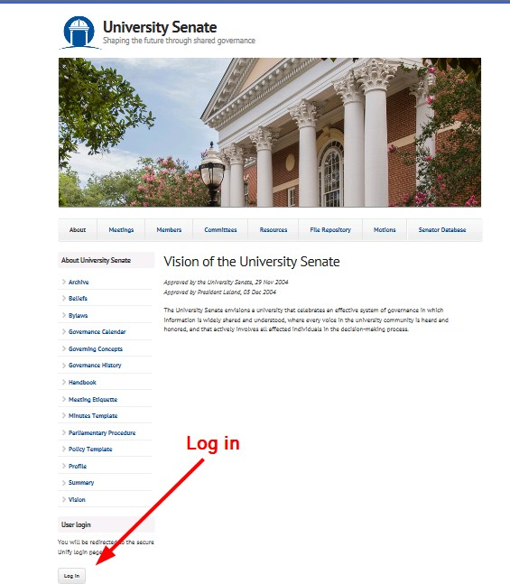

Accessing and Utilizing the Motion Database

Access Motion Database
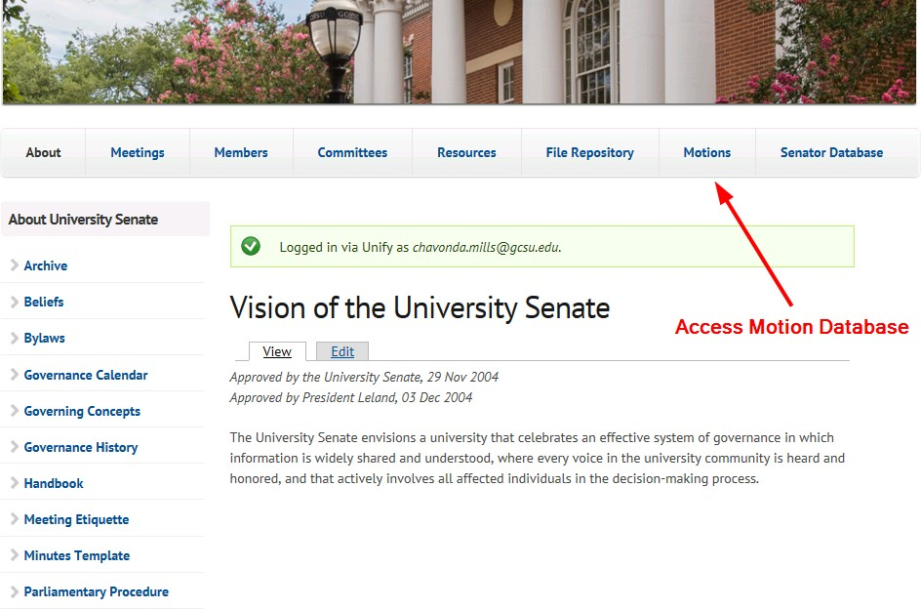

Add New Motion
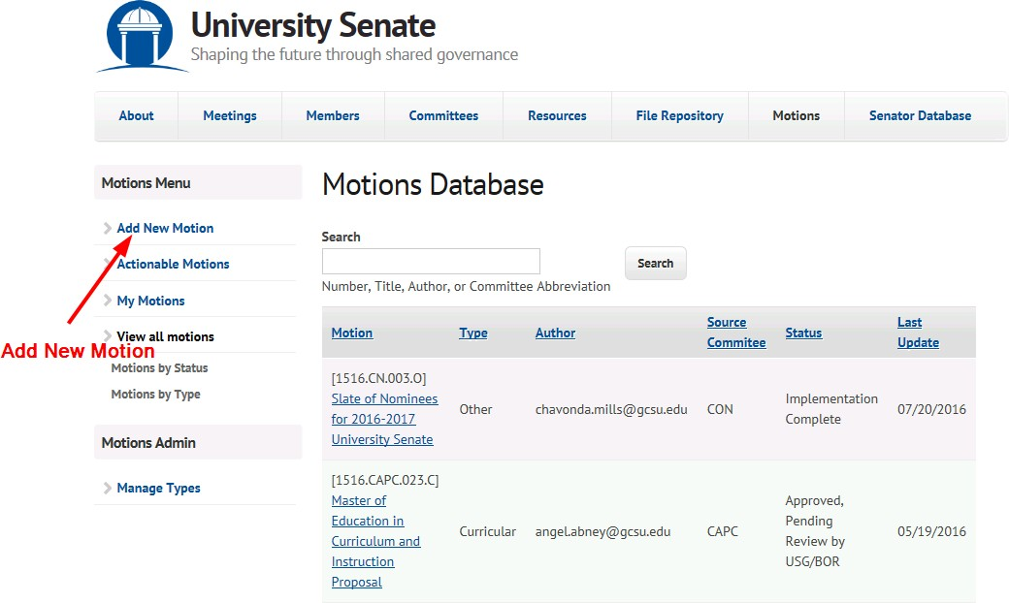

Complete Motion Entry Form and Save
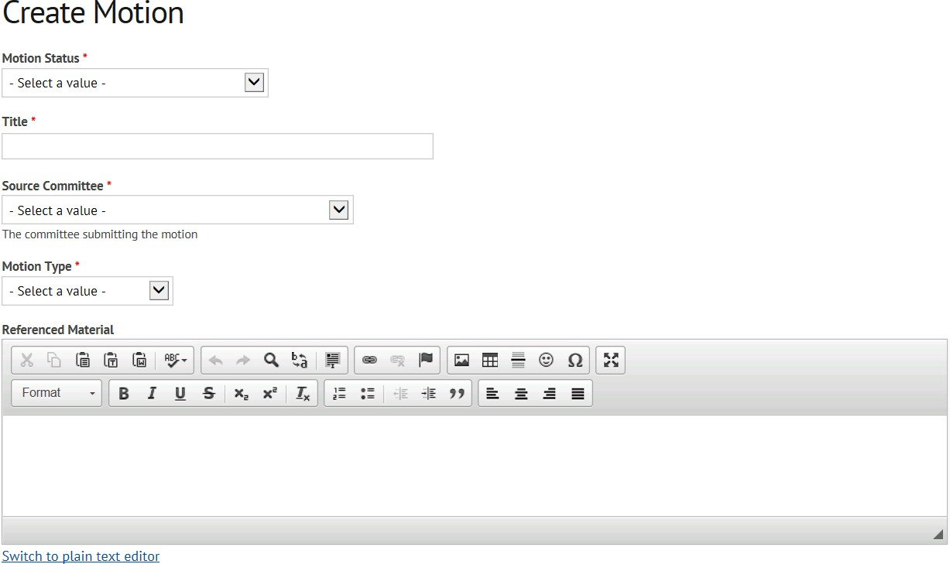
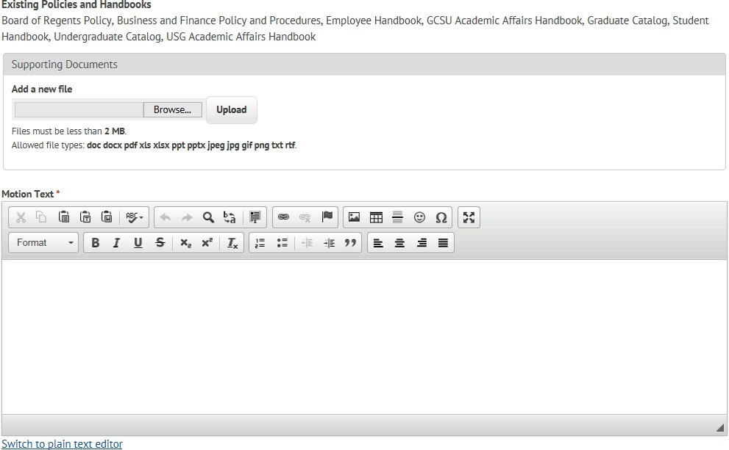

Accessing and Submitting Meeting Agenda through the File Repository

Access File Repository

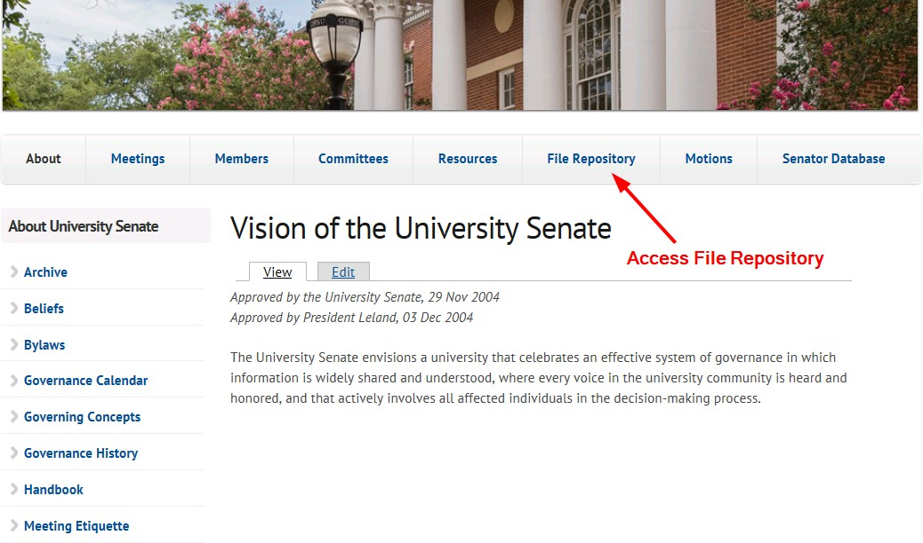
Select File Type, Public or Private
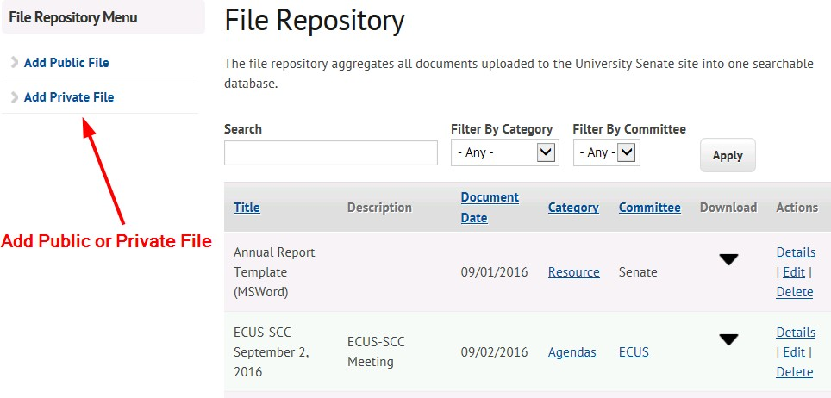

Complete Create Document Form and Save
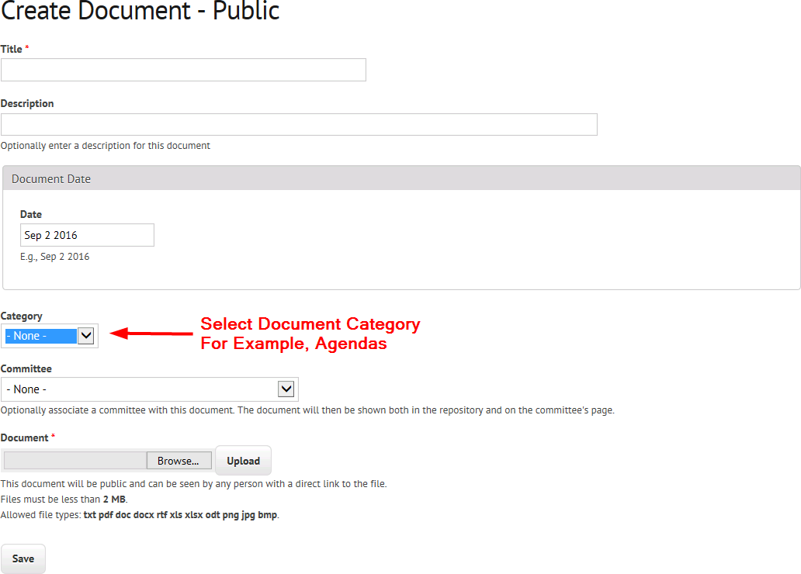

Submission of Minutes

Minutes Template

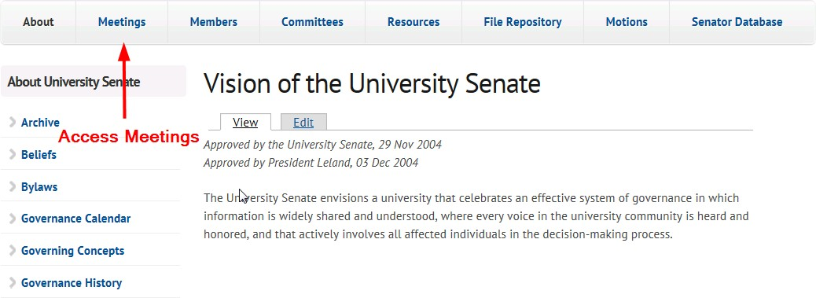
Access Minutes

Add Minutes
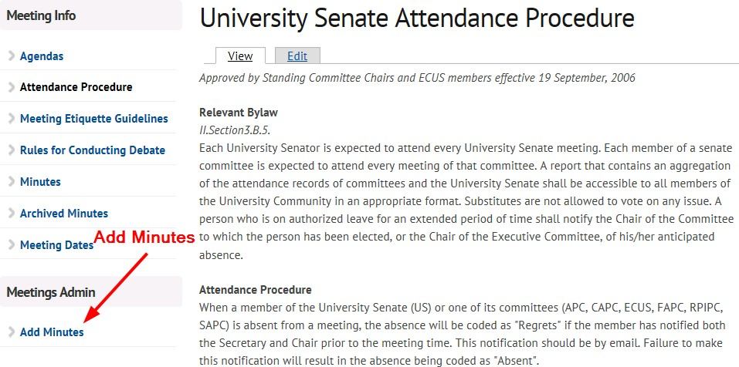

Complete Meeting Record with Minutes Form
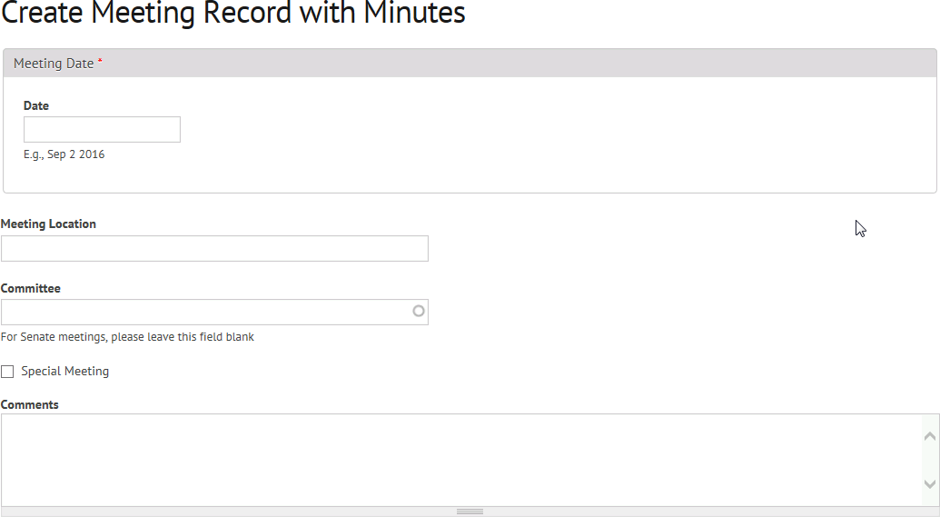
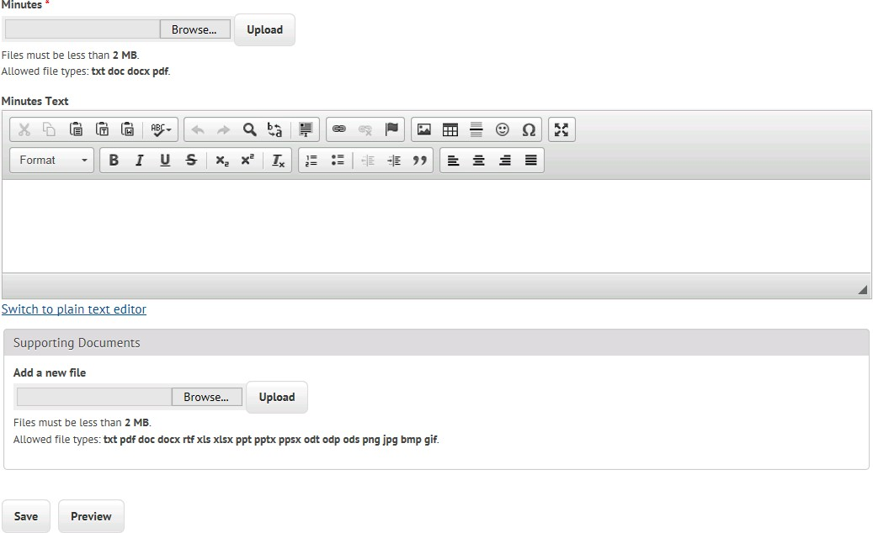

Senate Goals, Moving Forward
- What should be this year’s University Senate goals?
- What could the University Senate do to defend the core values of academic freedom?
- As the new GC Strategic Plan and QEP come into focus, what role do you see University Senate playing?

University Senate Meeting Agenda
Monday, 08 Aug 2022 at 11:45 AM, First United Methodist Church
 | Agenda Item and Presenter | Vote Required?
 | Call to Order – Jennifer Flory, Presiding Officer  Consent Agenda | NO
 | Consent Agenda – Jennifer Flory  Agenda/Minutes  - University Senate Meeting Agenda (08/08/2022)  - University Senate Meeting Minutes (04/22/2022) | YES (all University Senators vote)
 | Old Business  New Business | NO  NO
 | President’s Report – President Cox  Provost’s Report – Provost Spirou | NO  NO
 | Standing Committee Reports | NO
 | - Executive Committee of the University Senate (ECUS) – Jennifer Flory  - Subcommittee on Nominations (SCoN) – Rob Sumowski  - Academic Policy Committee (APC) – Chair (TBD)  - Diversity, Equity, Inclusion Committee – Chair (TBD)  - Faculty Affairs Policy Committee (FAPC) – Sabrina Hom  - Resources, Planning and Institutional Policy Committee (RPIPC) – Chair (TBD)  - Student Affairs Policy Committee (SAPC) – Chair (TBD)  - Student Government Association (SGA) – Kaitley Congdon | NO
 | Announcements/Information Items  - University Curriculum Committee (UCC) Update – Lyndall Muschell, UCC Chair | NO
 | Open Discussion | NO
 | Adjournment | YES (all University Senators vote)
Upcoming Events
- Friday 2 Sep 2022 2:00-3:15pm Standing Committees: APC, DEIPC, ECUS, FAPC, RPIPC, SAPC
- Friday 2 Sep 2022 3:30-4:45pm TBA: ECUS with Standing Committee Chairs
- Friday 16 Sep 2022 3:30-4:45pm Arts & Sciences 272: University Senate

