Template of University Senate Committee Annual Report
Due Date: Submit in Word format to senate@gcsu.edu no later than 5:00 p.m. on Wednesday 10 May 2023

Note: This report should represent consensus of the entire committee and serve as a historical record of committee deliberations over the academic year.

Committee Name: Academic Policy Committee

Academic Year: 2022-2023

Committee Charge:

V.Section2.C.1.a. Membership. The Academic Policy Committee shall have no fewer than eleven (11) and no more than thirteen (13) members distributed as follows: no fewer than nine (9) and no more than eleven (11) members selected from the Corps of Instruction faculty, at least seven (7) of whom are elected faculty senators, one (1) member who is the Chief Academic Officer or an individual appointed by the Chief Academic Officer to serve as a designee in compliance with V.Section2.C, and one (1) member appointed by the University President in compliance with II.Section1.A.5.

V.Section2.C.1.b. Scope. The Academic Policy Committee shall review and recommend for or against policy relating to undergraduate and graduate education matters that have broad impact or implication to the university as a whole, which includes, but is not limited to, policies relating to grading, scholastic probation and honors, academic appeals, academic standing, standards for admission, general university degree requirements, educational processes, academic calendar, academic assessment, and academic ceremonies. This committee also provides advice, as appropriate, on academic procedural matters at the institution which includes, but is not limited to, academic assessment and those matters relating to the educational process.

Committee Calendar:
Senate Retreat August 8, 2022
September 2, 2022
October 7, 2022 (canceled – no discussion items)
November 4, 2022
January 6, 2023 (via zoom)
February 10, 2023
March 3, 2023
April 14, 2023 (canceled – no discussion items)

Executive Summary:
Topics of discussion:
- Double Bobcats Pathway: APC assisted with reviewing and approving language of the Pathway. We put forth a motion to the senate to adopt this pathway as university policy. It was voted in.
- Proposal to draft a resolution to USG to make GCSU test optional for next academic year: APC discussed drafting a resolution; however, the president and provost were already on this topic and discussing with USG, we decided to table this discussion unless specifically called upon to submit such document. We were not requested to send a document to USG in support of being test optional
- DEIPC collaboration on syllabus statement inclusion on diversity & inclusion: A DEIPC representative visited 2 APC meetings, and an APC representative visited 1 DEIPC meeting to discuss the DEIPC proposed language for a syllabus statement inclusion. DEIPC requested APC cosponsor a motion to the senate to make their policy included in the list of required syllabus statements. Although APC supports the effort and recognizes this is an important issue, we felt as written it was not a statement that belonged in a syllabus statement and therefore voted to not cosponsor the motion. We provided additional suggestions for how to disseminate this information in other meaningful ways.
- Reviewed all syllabus statements: APC reviewed the current required syllabus statements for clarity and also to see if any were outdated, needed revisions, or could be eliminated. We determined all existing syllabus statements were important to remain included and did not require any revisions.
- Artificial intelligence concerns: APC discussed the concern of AI, specifically surrounding the plagiarism policy. We consulted with university counsel for legal guidance on amending the plagiarism policy; however, we were encouraged to wait on any USG guidance related to this emerging topic. As such, we did not make any suggestions for amendments.

Committee Membership and Record of Attendance:
Sarah Myers: chair
Benjamin “Chad” Whittle: vice chair
David Zoetewey: secretary
Identify all members of the committee, clearly indicate committee officers (Chair, Vice Chair, Secretary), and status of each member (Senator, non-Senator, student) along with a record of each member’s attendance. Note: this may be available as a download from the online senator database.

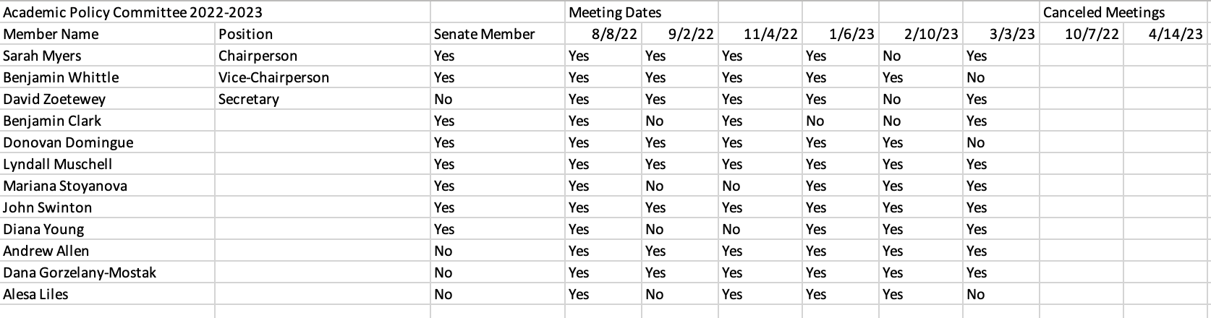

Motions brought to the Senate floor:
Motion Number: 2223.APC.001.P
Source Committee: Academic Policy Committee
Motion Status: Implementation in progress (as of 4.27.23)
Motion Type: Policy Recommendation

Motion Text:
Motion to endorse policy recommendation regarding the Double Bobcats Pathway.

Proposed policy language: “Students admitted to an approved Double Bobcat pathway may take up to 12 semester hours of pre-approved graduate credit as an undergraduate student and apply the credit to both the undergraduate and graduate degree requirements.”

The origin of this policy began with the Graduate School and has been reviewed thus far by multiple graduate coordinators, the Graduate Council, and APC. We hope this new policy (attached) will provide a structured pathway, as the current policy does not have universal structure. Furthermore, the new policy would allow an increase of credits for completion within the pathway from a maximum of 6 credits to a maximum of 12 credits which can help students from a financial perspective as they work toward a graduate degree given the Hope Zell scholarship can pay for these courses during undergraduate coursework. Since the graduate credits would be nontransferable to other institutions, the adoption of this pathway into policy will help with retention of our Georgia College undergraduate students into our graduate programs. It will also help us remain competitive with other universities in Georgia as many already offer similar programs (UGA, for example). Adopting policy for this pathway will make the process more visible across campus and assist with transparency to advisors, students, parents, and faculty.

Committee Vote to move motion to Senate: unanimous
Senate Vote: Motion 2223.APC.001.P was APPROVED by voice vote with no additional discussion and with no dissenting voice and only elected faculty senators eligible to vote.

Other Significant Deliberation (Non-Motions):
None

Ad hoc committees and other groups:
None

Committee Reflections:
What worked well: meeting agendas, minutes, and other supporting documentation were provided to the committee in a timely manner, meetings were time efficient, members of APC were willing to sit in on other committee’s meetings as well as inviting external university representatives as needed to engage in collaborative discussions. There was a good mix of new and returning senators on the committee which was helpful in providing guidance to the nuances of governance as all 3 executive members of the committee (chair, vice chair, secretary) were all new senators.

What could use improvement: At this time there are no suggestions for improvement. The committee worked well together this year and was able to address all topics we were charged as well as being proactive in addressing additional areas of concern.

Committee Recommendations:
Advice to the membership of the committee for the next academic year such as: Secure the meeting location for all scheduled meetings early. Be sure to allow all voices that wish to speak to be heard.
Are there any issues that should be considered by this committee the following year? No
Are there any issues that this year's committee was unable to complete its work on? No
Do any of this year's committee actions require follow-up? (i.e. a policy was drafted, but there was a recommendation for a review of the policy during the following year.) No
Recommendations on calendar (meeting times, outline items that you expect would be considered annually): None

Recommend items for consideration at the governance retreat: None

Appendix: Committee Operating Procedures
The committee elected to retain the operating procedures from the previous year:

“In terms of SOP, the committee agreed to keep meetings rather informal, except for votes on policies. APC is composed of 13 members, so there will need to be 7 members present to establish a quorum. To conduct committee business. Other SOP items of committee agreement were to bring up agenda items early; to be respectful of when meetings begin and end; to require approval of extended time at regularly scheduled end of an APC meeting; require consensus before new items for discussion are brought to the attention of ECUS; and when possible, to invite guests to clarify information related to committee discussions.”

We also acknowledged that US operating procedures permit for electronic discussion of items if achieving and maintaining a quorum becomes difficult.

