2023 Standing Committee Officer Training
Table of Contents
2023-24 University Senate, Standing Committee, and ECUS with Standing Committee Chairs Meetings 2
2024-25 University Senate Organizational Meeting 2
Highlights from 2022-23 and Items on the Horizon in 2023-24 2
Academic Policy Committee (APC) 2
Diversity, Equity, and Inclusion Policy Committee (DEIPC) 3
Faculty Affairs Policy Committee (FAPC) 3
Resources, Planning, and Institutional Policy Committee (RPIPC) 4
Student Affairs Policy Committee (SAPC) 5
Sub-Committee on Nominations (SCoN) 5
Standing Committee Officer Training (elected officers of senate committees) 5
Standing Committee Officer Responsibilities 5
Standing Committee Chairs 5
Standing Committee Vice-Chairs 5
Standing Committee Secretaries 5
Responsibilities to be Assigned or Defined by the Committee 5
Pertinent University Senate Bylaws 5
Ongoing Committee Reminders 6
Standing Committee Scopes 7
Required Written Reports 7
Committee Chair to University Senate 7
Committee Annual Report 8
Standing Committee Chairs with Executive Committee 8
Purposes of Motions 8
University Senate Website Navigation 9
University Senate Management System: Log in with UNIFY username and password 9
Accessing and Utilizing the Motion Database 10
Accessing and Submitting Meeting Agenda through the File Repository 12
Submission of Minutes 14

2023-24 University Senate, Standing Committee, and ECUS with Standing Committee Chairs Meetings
- Friday 28 Apr 2023 3:30-4:45pm Arts & Sciences 272: University Senate Organizational Meeting, including Standing Committee Organizational Meetings
- Monday 14 Aug 2023 9:00-2:00pm First United Methodist Church: Governance Retreat, including Standing Committee Organizational Meetings
- Friday 1 Sep 2023 2:00-3:15pm Standing Committees: APC, DEIPC, ECUS, FAPC, RPIPC, SAPC
- Friday 1 Sep 2023 3:30-4:45pm Parks 301: ECUS with Standing Committee Chairs
- Friday 15 Sep 2023 3:30-4:45pm Arts & Sciences 272: University Senate
- Friday 6 Oct 2023 2:00-3:15pm Standing Committees: APC, DEIPC, ECUS, FAPC, RPIPC, SAPC
- Friday 6 Oct 2023 3:30-4:45pm Parks Hall 301: ECUS with Standing Committee Chairs
- Friday 20 Oct 2023 3:30-4:45pm Arts & Sciences 272: University Senate
- Friday 3 Nov 2023 2:00-3:15pm Standing Committees: APC, DEIPC, ECUS, FAPC, RPIPC, SAPC
- Friday 3 Nov 2023 3:30-4:45pm Parks Hall 301: ECUS with Standing Committee Chairs
- Friday 17 Nov 2023 3:30-4:45pm Arts & Sciences 272: University Senate
- Friday 5 Jan 2024 2:00-3:15pm Standing Committees: APC, DEIPC, ECUS, FAPC, RPIPC, SAPC
- Friday 5 Jan 2024 3:30-4:45pm Online: ECUS with Standing Committee Chairs
- Friday 19 Jan 2024 3:30-4:45pm Arts & Sciences 272: University Senate
- Friday 9 Feb 2024 2:00-3:15pm Standing Committees: APC, DEIPC, ECUS, FAPC, RPIPC, SAPC
- Friday 9 Feb 2024 3:30-4:45pm Parks Hall 301: ECUS with Standing Committee Chairs
- Friday 23 Feb 2024 3:30-4:45pm Arts & Sciences 272: University Senate
- Friday 1 Mar 2024 2:00-3:15pm Standing Committees: APC, DEIPC, ECUS, FAPC, RPIPC, SAPC
- Friday 1 Mar 2024 3:30-3:15pm Parks Hall 301: ECUS with Standing Committee Chairs
- Friday 15 Mar 2024 3:30-4:45pm Arts & Sciences 272: University Senate
- Friday 5 Apr 2024 2:00-3:15pm Standing Committees: APC, DEIPC, ECUS, FAPC, RPIPC, SAPC
- Friday 5 Apr 2024 3:30-4:45pm Parks Hall 301: ECUS with Standing Committee Chairs
- Friday 26 Apr 2024 2:00-3:15pm Arts & Sciences 272: University Senate

2024-25 University Senate Organizational Meeting
- Friday 26 Apr 2024 3:30-4:45pm Arts & Sciences 272: University Senate Organizational Meeting
- TBA: 2004-2005 Governance Retreat

Highlights from 2022-23 and Items on the Horizon in 2023-24

Academic Policy Committee (APC)
- The committee had discussions of various issues related to the Double Bobcats Pathway, whether GCSU would be test-optional for the 2023-2024 school year, collaborated with DEIPC on the syllabus statement dealing with inclusion on diversity & inclusion, and discussed the concern of AI, specifically surrounding the plagiarism policy.
- The committee made one significant motion to endorse the policy recommendation regarding the Double Bobcats Pathway, which was approved by University Senate and acknowledged by President Cox. APC made referrals of other matters to appropriate committees.
- The committee recommended that the 2023-2024 committee secure the meeting location for all scheduled meetings early and to be sure all voices that wish to speak are heard.

Diversity, Equity, and Inclusion Policy Committee (DEIPC)

Pending receipt.

Executive Committee of the University Senate (ECUS)
- The committee continued recurring activities such as holding the annual governance retreat; designating the Sub-committee on Nominations (SCoN); preparing and distributing agendas and minutes for ECUS, ECUS with SCC, and University Senate meetings; providing oversight of faculty senator elections and appointment of University Senate representatives to university-wide committees and task forces, etc.
- Topics for Continuing Consideration:
  - Electronic Presence of the University Senate – continue test-driving, consider publishing governance calendar to 25Live
  - University Senate Budget and Foundation accounts (how they are used)
  - Continue how best to receive updates from university senate representatives on task forces and committees.
  - Consider how much detail is necessary in standing committee chair reports to ECUS-SCC, highlights or details? Important that these reports are archived in electronic minutes including information items.
  - Consult with Legal Affairs/Compliance Officer regarding compliance language on the Policy Template.
  - Review current practices of and recommend best practices for the maintenance of the Policies, Procedures and Practices Manual, specifically regarding, first, the creation of an annually released pdf version of the manual and, second, incorporating notations regarding who, when, and why updates to the manual are made.
  - Review the new governance retreat format and venue.
  - Review University Senate archival processes (senate.gcsu.edu, us.gcsu.edu, and minutes.gcsu.edu), and explore the possibility of consolidation.

Faculty Affairs Policy Committee (FAPC)
- The committee worked with ECUS and the office of the Provost to fill a gap in GCSU policy and allow faculty to pause the clock for a Post-Tenure Review (PTR). After an initial recommendation was revisited following consultation with the Provost’s office, the committee presented a motion which allows clock stoppages only for those who have taken FMLA leave. In drafting this policy, the committee prioritized confidentiality for the PTR candidate (stressing in the policy language that it is not necessary to disclose the reason for FMLA leave) and worked to maximize the time period in which a candidate can apply for a clock stoppage. In addition, the committee discussed the ongoing process to update Departmental and College policies on T&P and annual evaluations in light of the BOR’s revisions to PTR and other evaluation policies. Finally, the committee was informed of a revision to the Amorous Relationship Policy and engaged with Human Resources to understand the policy and discuss interpretation and implementation. A number of questions and inconsistencies emerged in this conversation, which were discussed and largely resolved in subsequent meetings.
- The committee made two motions as listed below. The first was withdrawn and its replacement was approved by University Senate and approved, acknowledged, and/or implemented by President Cox.
  - Motion to permit extensions to the Post-Tenure Review period for specified family and medical reasons, withdrawn January 6, 2023.
  - Motion to Create a Post-Tenure Review Period Pause Policy, passed April 14, 2023.
- The committee recommended that FAPC should continue to track issues around Post-Tenure Review (PTR), as well as workload issues and numbers of part-time faculty related to current budget issues and the large incoming class. It noted that each year, FAPC is asked to address issues related to faculty evaluations, especially Student Ratings of Instruction. University wide policy seems to be largely in sync with Faculty interests. The committee suggested that future FAPC chairs be careful about how and when to engage this issue, since many of the concerns take place at the department or college level. Furthermore, it suggested that further efforts to alter the SRIS start from the Center for Teaching and Learning since they have the most knowledge about evaluation and also the capacity to maintain committees for more than one academic year, to start pilot programs and do institutional research.
Further, after examining BOR policy changes to the Amorous Relationship policy, the committee recommended that ECUS/Committee chairs be aware of all revisions to the Policies, Procedures and Practices Manual (PPPM) and to invite relevant speakers in to discuss these as informational items so that faculty are made aware of relevant changes that affect faculty. The committee should carefully read over the policy ahead of time and be ready to ask granular questions. Especially since these policies are often handed down quickly and with little discussion by the BOR, it is important to have some thoughtful conversations about what exactly the policies mean, how they will impact faculty, and how to handle them. These conversations can be formative in terms of policy interpretation and implementation.
- Upcoming issues for the committee to consider include:
  - Addressing a possible loophole within the current Emeritus Policy causing confusion by contradicting another section of the policy, and it is recommended that FAPC examine the issue to decide whether to make any relevant recommendations. Details have been shared with the incoming chair, who will present to the committee in Fall 2023.
  - FAPC is asked to examine the Final Exam Policy and suggestions from the Office of Academic Affairs. Details have been shared with the incoming chair, who will present to the committee in Fall 2023.

Resources, Planning, and Institutional Policy Committee (RPIPC)
- The committee primarily discussed issues ranging from administrative privileges on computers/Macs, the GCSU Parking Policy, revisions to the Amorous Relationship Policy, and a request for the BOR to provide funding to meet the shortfall in state appropriation resulting from the decision for GCSU to remain test-required during the admission of the incoming class for Fall Semester 2022.
- The committee brought two motions which were both approved by University Senate and acknowledged by President Cox.
  - Motion to request that the Board of Regents consider bridge funding for the enrollment shortfall based on unintended consequences of the 2022-2023 standardized testing requirement
  - Motion to request a review and update of the GCSU Parking Allocation Policy
- The committee made recommendations that the 2023-2024 RPIPC committee follow-up on the two motions submitted during 2022-2023, examine an Amorous Relationship Policy implementation strategy, the possibility of a centralized IT spending strategy as a potential cost saving measure, and evaluation of the 2023 modified summer schedule to learn whether the new policy met its objectives and how the new summer schedule was perceived by staff and faculty.
- RPIPC leadership requested that the Executive Cabinet consider sharing a list of policy and/or resource changes intended to for the academic year so that RPIPC can align its agenda to provide input from faculty and staff.

Student Affairs Policy Committee (SAPC)

Pending receipt.

Sub-Committee on Nominations (SCoN)
- SCoN prepared apportionment of elected faculty senators based on the corps of instruction list from the Provost’s office. SCoN worked with the deans and library director on faculty senator elections for each college and the library and facilitated and oversaw the at-large faculty senator election. SCoN asked for nominations for senate officers and volunteers for standing committees and university-wide committees. SCoN held an election between two elected faculty senator nominees for Presiding Officer Elect.
- The sub-committee submitted motions for a revised slate of nominees for 2022-23 university senate officers and university senate committee members during the 2022-2023 school year. The sub-committee also submitted a motion with the slate of nominees for 2023-24 university senate officers and university senate committee members in April. All three motions were approved by University Senate and acknowledged by President Cox.

Standing Committee Officer Training (elected officers of senate committees)

Standing Committee Officer Responsibilities

Standing Committee Chairs
    - Eligibility: Elected Faculty Senators who are members of the standing committee
    - Post standing committee meeting agendas to the Senate website. Email the US secretary written reports after ECUS-SCC and University Senate meetings.
    - Bylaws Responsibilities:
        - Present Committee Report to University Senate at scheduled University Senate meetings (Article II, Sec 3.A.3)
        - Submit such reports to University Senate Secretary in appropriate format for minutes (Article II Section 3.I)
        - Transfer committee records to the following year's committee (Article IV, Sec 3.B)
        - Meet regularly with the Executive Committee and other chairs to facilitate communication (Article V, Sec 1.C.14)
        - Serve on the Subcommittee on Nominations (Article V, Sec 1.D.1.a)
        - Be notified by a committee member who is going on extended leave (Article II Section 3.H)
        - Be consulted by ECUS on due date and format of comprehensive annual report of committee (Article IV, Sec 2)
        - Be consulted by ECUS on steering any matter to a standing committee (Article V, Sec 1.C.4)
    - Other Responsibilities:
        - Be contacted by committee members extending regrets prior to the meeting
        - Others as defined by the committee

Standing Committee Vice-Chairs
- Eligibility: Any member of the standing committee
- Bylaws Responsibilities: None
- Other Responsibilities:
- Assumes all duties and responsibilities of the Committee Chair in the absence of the Committee Chair
- To be defined by the committee

Standing Committee Secretaries
- Eligibility: Any member of the standing committee
- Post standing committee meeting minutes to the Senate website.
- Bylaws Responsibilities: The secretary of the committee shall post the minutes of a committee meeting prior to the call to order of the next meeting of the committee. This includes minutes of any subcommittee or ad hoc committee that reports to it. (Article V, Section 2.B.3)
- Other Responsibilities:
- Be contacted by committee members extending regrets prior to the meeting
- To be defined by the committee

Responsibilities to be Assigned or Defined by the Committee
- Chairs or secretaries, please email the US secretary approved operating procedures and he will post them to the Senate website
- When a vacancy on the committee occurs, a replacement determined in same manner
- Scheduling meeting rooms, times, and dates for committee meetings
- Conducting meetings (preside at meetings)
- Conducting forums
- Supplying an agenda for committee meetings with electronic documentation
- Establishing operating policies/procedures and filing with ECUS
- Writing and submitting a comprehensive, written annual report
- Entering motions in the online motion database to get a motion on the floor of Senate
- Ad hoc committee registry form submission
- Advertising Meeting Times and Agenda to the University Community
- Promoting the Governing Concepts of the University Senate in order to increase the university community’s capacity for shared governance

Pertinent University Senate Bylaws
- IV.Section3.A. Organizational Meetings. Within ten (10) calendar days of the spring organizational meeting of the incoming University Senate for the subsequent academic year, each of the incoming standing committees shall hold a meeting at which they elect committee officers in accordance with V.Section2.B.1. The Executive Committee shall designate a facilitator to both preside at this meeting and conduct the elections of the committee officers. Should there be any unfilled positions on the incoming committee, specifically members not known by name such as SGA appointees, Presidential Appointees named by title, etc., the Executive Committee shall name voting proxies for the elections of the committee officers from the pool of outgoing committee members.
- V.Section2.B.1. Officers. The members of a standing committee shall elect a chair, a vice-chair, and a secretary by secret ballot in accordance with IV.Section3.A. Only elected faculty senators are eligible to serve as the committee chair, but any member of the committee is eligible to serve as vice-chair or secretary. The chair, vice-chair, and secretary shall be elected for a period of one year. The chair, vice-chair, or the secretary may be reelected.

Ongoing Committee Reminders
- Options for working groups
  - subcommittees (requires bylaws change),
  - ad hoc committee (formal – Bylaws V.Section2.A.3.b. requires a charter in consultation ECUS)
  - information gathering group (informal)
- Be intentional on sharing information with the entire University Community. This might include the identification of particular committee members to share information with students, staff, faculty, administration.
- Copy monthly committee meeting agenda to standing committee chairs executive committee when distributing it to committee members to keep all in the information loop.
- Upload monthly committee meeting agenda to Senate website.
- At the end of each monthly meeting, consider having the secretary summarize the meeting (this allows committee members to clarify the draft minutes while the meeting is still “fresh” in their minds).
- At the end of each monthly meeting, consider setting tentative agenda of the following meeting.
- Consider overflow meeting time when drafting/revising committee operating procedures.
FYI: From 11-21-06 ECUS meeting: Suggested that for both the larger group and Standing Committees that when motions are made that someone other than the presiding officer (such as the Administrative Assistant or Past Presiding Officer) track and display in a prominent way the motion statement in the meeting room reflecting any amendments to a motion so that Senators or committee members are able to see the exact motion statements including amendments made from the floor during debate and when they vote on the motions.

Standing Committee Scopes
- V.Section2.C.1.b. Scope. The Academic Policy Committee shall review and recommend for or against policy relating to undergraduate and graduate education matters that have broad impact or implication to the university as a whole, which includes, but is not limited to, policies relating to grading, scholastic probation and honors, academic appeals, academic standing, standards for admission, academic calendar, and academic ceremonies. This committee also provides advice, as appropriate, on academic procedural matters at the institution.
- V.Section2.C.2.b. Scope. The Diversity, Equity, and Inclusion Policy Committee shall review and recommend for or against policy related to inclusion, equity, and diversity, which includes, but is not limited to, policies relating to all institutional aspects of equitable access, success, and education of the university community on issues of diversity, inclusion, state and federal laws regarding protected classes, and university language relating to non-discrimination and diversity. In addition, this committee shall review and provide advice on procedures, guidelines, and employee and student professional development relating to institutional climate and priorities for ensuring justice, fairness, and equitable treatment to all members of the university.
- V.Section2.C.3.b. Scope. The Faculty Affairs Policy Committee shall review and recommend for or against policy relating to faculty welfare (e.g. authorities, responsibilities, rights, recognitions, privileges, and opportunities), which includes, but is not limited to, policies relating to academic freedom, workload, compensation, recruitment, retention, promotion, tenure, recognitions, development, and instructional support. This committee also provides advice, as appropriate, on procedural matters that affect the welfare of the faculty.
- V.Section2.C.4.b. Scope. The Student Affairs Policy Committee shall review and recommend for or against policy relating to the general social, cultural, and practical welfare of students, which includes, but is not limited to, policies relating to non-academic areas such as conduct and discipline, grievances and non-academic appeals, financial aid, human services for students (e.g. health center, counseling), organizations, awards, intercollegiate athletics, and other extracurricular activities (e.g. Greek life, residence life, intramurals). This committee also provides advice, as appropriate, on procedural matters that affect the general social, cultural, and practical welfare of the students.
- V.Section2.C.5.b. Scope. The Resources, Planning, and Institutional Policy Committee shall review and recommend for or against policy relating to non-instructional personnel (including administrative personnel) and institutional budget and planning functions, which includes, but is not limited to, policies relating to recruitment, hiring, evaluation, welfare and development as well as compliance with local, state, and federal guidelines (e.g. affirmative action, ADA, homeland security), and institutional support functions of the university (e.g. technology, parking) In addition, this committee shall review and provide advice on master planning, strategic planning, and budgeting processes and provides advice, as appropriate, on other procedural matters that affect the general welfare of the institution and its employees.

Required Written Reports

Committee Chair to University Senate
- II.Section3.A.3. Reports. Each standing committee and the Executive Committee, through its duly elected chair, shall, at all regular meetings of the University Senate, make a brief oral report of business transacted by the committee since the previous meeting of the University Senate. In addition, II.Section3.I. applies to such reports.
- II.Section3.I. Reports. All reports given at a University Senate meeting shall be submitted in an appropriate format to the Secretary of the University Senate for inclusion in the minutes of that meeting.
- Minutes Template

Committee Annual Report
    - IV.Section 2. Reports. The committees listed in V.Section2.A.1 shall constitute the standing committees of the University Senate. Each standing committee and the Executive Committee shall present a comprehensive, written, annual report in an appropriate format to the Executive Committee. This report shall include a summary of the major items considered by the committee during the academic year and the disposition of each. The Executive Committee shall set a due date and the format of these reports in consultation with the standing committee chairs and these reports shall be posted with the minutes of the last University Senate meeting of the academic year.
    - Annual Report Template
    - Annual Reports Archive

Standing Committee Chairs with Executive Committee
- V.Section1.C.14. Standing Committee Chairs Coordination. The Executive Committee shall meet regularly with the Standing Committee Chairs to facilitate communication among the committees of the University Senate.
- In practice, at the joint meetings of the Standing Committee Chairs with Executive Committee, each standing committee chair provides a brief oral report. While not formally required by bylaws, submitting those reports electronically (email or MSWord format) to ECUS secretary is desirable (to the ECUS Secretary).

Purposes of Motions
- To RECOMMEND revisions to an existing policy
- To RECOMMEND revisions to existing University Senate Bylaws
- To ENDORSE procedural recommendations (more of a resolution than a motion; outside purview)
- To ENDORSE a resolution
- To RECOMMEND a new policy:
- Policy Template

University Senate Website Navigation

University Senate Management System: Log in with UNIFY username and password
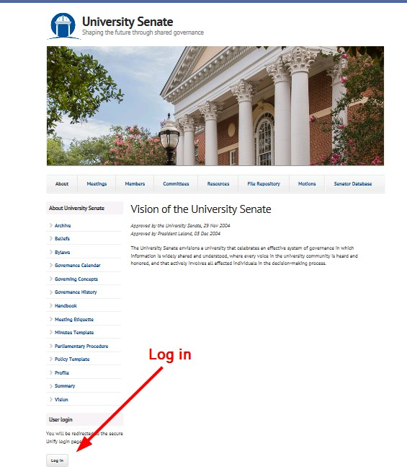

Accessing and Utilizing the Motion Database

Access Motion Database
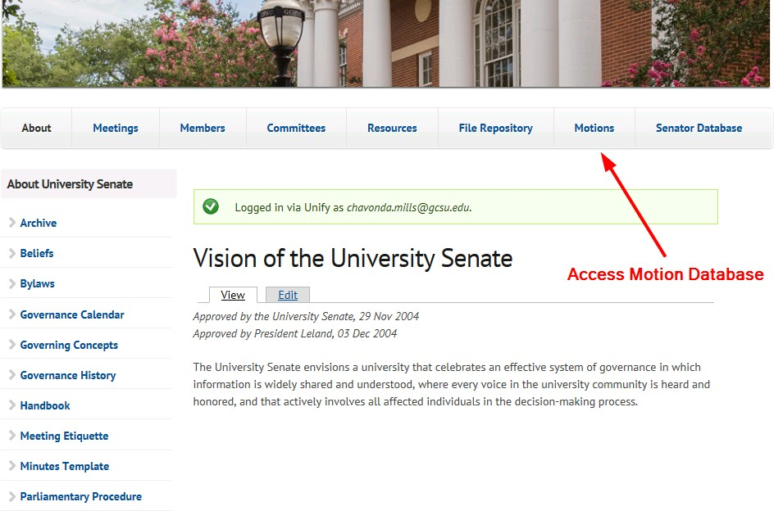

Add New Motion
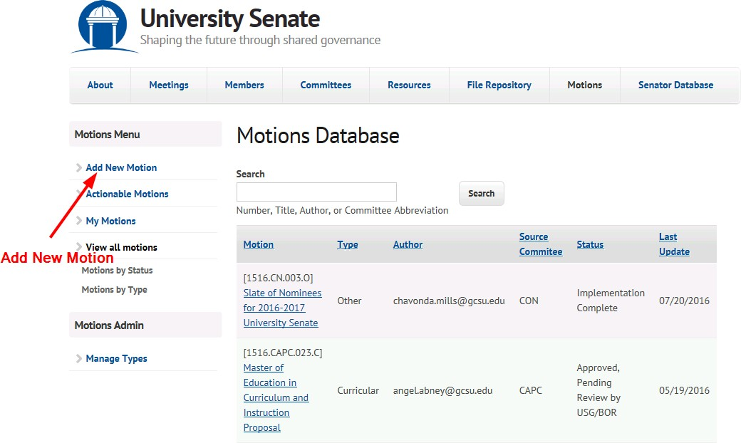

Complete Motion Entry Form and Save
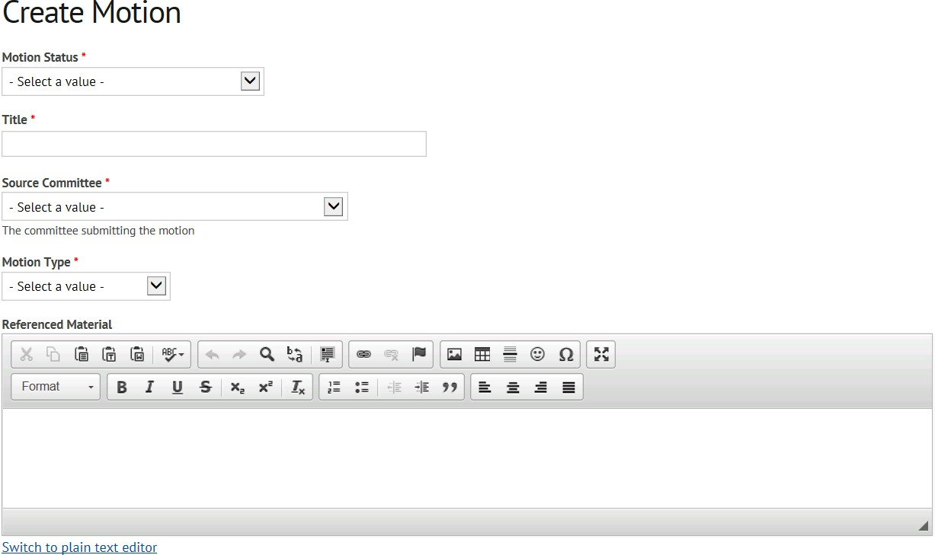
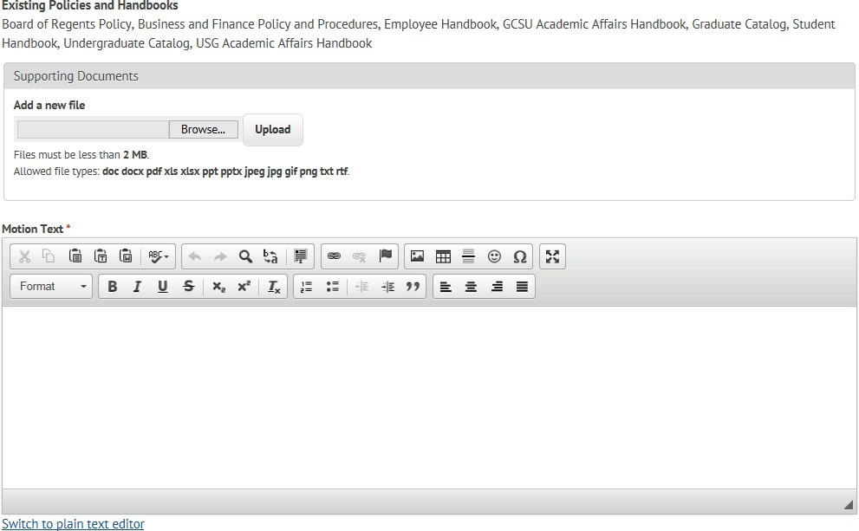

Accessing and Submitting Meeting Agenda through the File Repository

Access File Repository

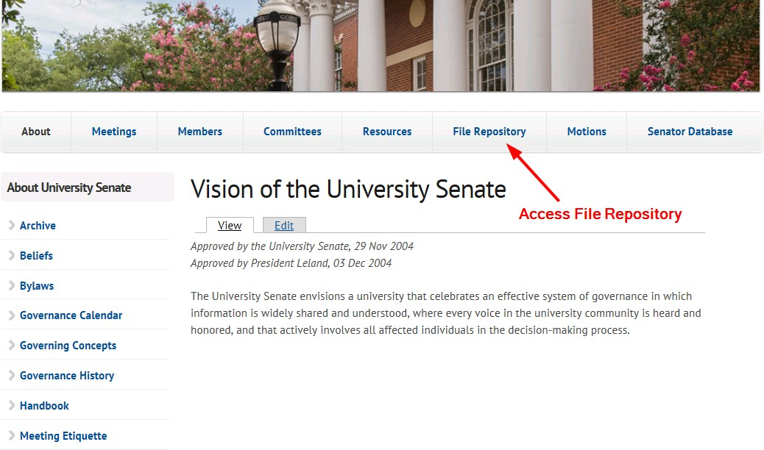
Select File Type, Public or Private
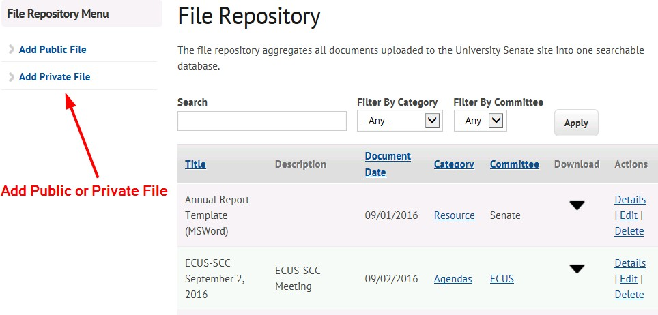

Complete Create Document Form and Save
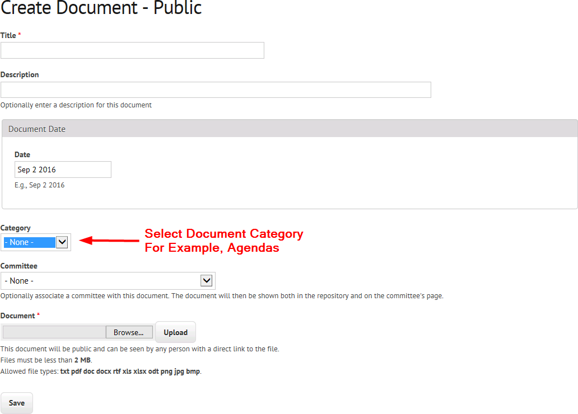

Submission of Minutes

Minutes Template

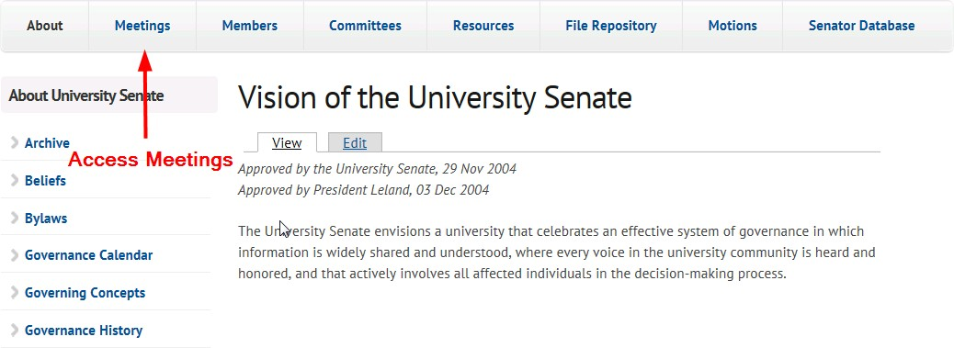
Access Minutes

Add Minutes
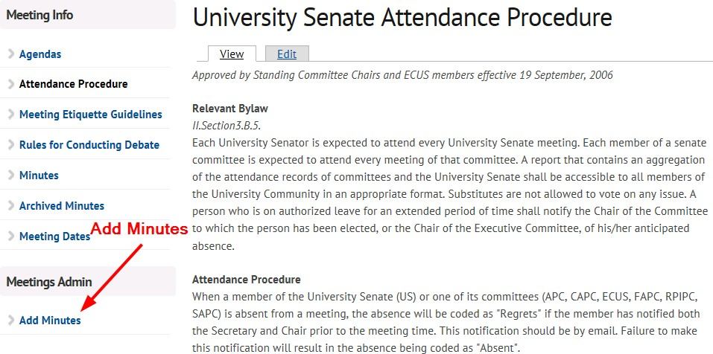

Complete Meeting Record with Minutes Form
