Governance Retreat Planning Work Group (GRPWG)
Report 2011

Presented to: Georgia College & State University’s Senate

September 2, 2011

Work Group Members:

Doreen Sams, Ph.D., Chairperson College of Business
Dean Baker, Ph.D., Member College of Health Sciences
Karynne Kleine, Ph.D., Co-Secretary College of Education
Craig Turner, Ph.D., Co-Secretary College of Arts & Sciences
Mike Rose, Ph.D., Member College of Arts & Sciences
Jan Clark, Ph.D., Ex Officio Member College of Arts & Sciences

Summary Brief

The Georgia College Governance Retreat Work Group (GRWGP) functions as the planning committee for the annual governance retreat. This year’s work group consisted of six members (1 – College of Business, 1 College of Education, 1 Health, and 3 from Arts & Sciences). The group met seven times beginning at the end of the spring semester and the remainder during the summer). The group was charged with informing the University Senate of the dates, time and place for the event as well as the theme “Pumping up the Flow: Shared Governance as the Heart of GC.” Members of the University Senate were surveyed as to their plans to attend the upcoming August 10, 2011 retreat and their preferences as to food and refreshments. Based on feedback from the University Senate, the GRWGP forged plans for the events. The following report contains key accomplishments of the group on a meeting-by-meeting basis. Next, the report provides findings from a survey of retreat attendees as to their level of satisfaction with each event. The next portion reports, “what worked” and puts forth recommendations. Details are provided in the appendices and include copies of surveys, analyses, and forms used by the GRWGP.

It was the pleasure of the members of the GRWGP to serve the 2011-2012 University Senate in their duties as work group members. The information contained in this report is expected to be useful in planning the 2012-2013 GC governance retreat.

GRPWG Initial Processes

The Executive Committee of the University Senate (ECUS) has a number of reoccurring tasks for which it is responsible; one of them is planning the annual governance retreat. Oftentimes a member of ECUS is designated to serve as the chair for the governance retreat planning work group (GRPWG). In 2010-2011, this did not occur, but rather the membership of the GRPWG was determined by soliciting volunteers at the Nov 2010 meeting of the University Senate. Those volunteering were Mike Rose, Dean Baker and Craig Turner. Subsequently, Karynne Kleine volunteered at another meeting of ECUS and Tanya Goette agreed to identify a College of Business representative, securing Doreen Sams as a volunteer. Finally Jan Clark, in her role of Presiding Officer of the 2011-2012 University Senate, attended a number of work group meetings and was added as a work group member. Generally this work group includes representatives from each of the academic colleges and the library as well as the staff. In 2010-11, the work group chair sought representatives from the library and staff but none emerged. Once underway the work group members listed above began collectively working to plan the 2011 Governance Retreat scheduling it, in consultation with ECUS, for August 10, 2011. More experienced members mentored the Chairperson as she was new to the group and to the University Senate.

2011 GRPWG Official Meetings were Held

February 8 - Kilpatrick Second Floor outside Suite 228
March 9 - Kilpatrick Second Floor outside Suite 228 (Glassroom)
April 6 - Kilpatrick Second Floor outside Suite 228
April 27 - Kilpatrick Second Floor outside Suite 228
July 14 - Kilpatrick Second Floor outside Suite 228
August 4 - Kilpatrick Second Floor outside Suite 228 (Glassroom)
August 10 - West Campus (Set up and last minute touches)

Meeting and Event Preparation Highlights

February 8, 2011 - GRPWG Meeting Highlights
- Explained the role of officers of the work group and selected officers
- Determined a proposed date of the governance retreat (August 10, 2011)
- Determined the location for the governance retreat (GC West Campus Center)
- Members of the work group were made aware of the URL for the 2009-2010 governance retreat work group http://info.gcsu.edu/intranet/univ_senate/Retreat_10/ to review materials from the 2010 retreat.
- Decided that the secretary would also E-mail minutes to all members of the work group for their review prior to posting as the “official” minutes.
- Set the date and place for the next meeting of the GRPWG
- Prepared and printed the “attendance” survey (revised from previous year’s survey) for distribution at the February 2011 meeting of the University Senate (See Appendix A for questionnaire)
- It was determined that the GRPWG Chair would ensure that the survey was distributed to and collected from current University Senators at the February 2011 University Senate meeting and prepare a report summarizing the responses for the next GRPWG meeting

March 9, 2011 – GRPWG Meeting Highlights
- Reported on and reviewed the report of the information gathered from survey collected at the February 2011 meeting of the University Senate to make decisions about the retreat (See Appendix B for first survey preliminary results report).
- Based on limited feedback from the surveys and the past experience of GRPWG members, all members of the group were given until the next meeting to come up with ideas on the retreat sessions.

April 6, 2011 – GRPWG Meeting Highlights
- Per a request from ECUS, the work group designated a member of the GRPWG to speak at the April 18th and 22nd University Senate meetings about filling out survey [Appendix A] and to promote the retreat – The work group chair contacted the Presiding Office of the University Senate requesting time for a member of GRPWG to speak
- Suggestions [specifically university senate leader selection and the senator election calendar] were formulated for ECUS as to discussions for the University Senate meeting held on August 10 following the formal retreat sessions and prior to the retreat reception
- A connectivity of themes through the retreat and the Senate meetings were decided upon at this meeting that guided the remainder of the GRPWG meetings
- A request to consider obtaining information from standing committee chairs [impressions of the level of participation as well as attendance record of members of the standing committees] was made by committee chair [Doreen Sams] of ECUS vice-chair [Jan Clark] for ECUS consideration as neither of the ECUS members on the GRPWG [Karynne Kleine, Dean Baker] were able to attend the April ECUS meeting

April 27, 2011 - GRPWG Meeting Highlights
- Reviewed the survey results from the April 2011 Senate meetings and combined them with the earlier report (See Appendix C for revised report).
- The GRPWG chair was encouraged to contact Monica Starley in the University President’s office for a budget for food and supplies.

July 14, 2011 - GRPWG Meeting Highlights
- GRPWG reported that a budget of $1,800 was given and that Monica Starley requested that she be included as a recipient in any E-mail messages with Sodexo about the food for the retreat
- Jan Clark, Senate Presiding Officer, joined the work group
- Reviewed the working draft of the retreat agenda and made minor adjustments
- Contacted facilitators of sessions of the retreat to determine needs [supporting documents to be included in the retreat participant packet, office supplies to implement her/his session]
- Coordinated with Monica Starley (President’s Office) regarding:
- Budget (President’s office signs catering contracts after the work group agrees to them)
- Catering regarding food/beverages for lunch and breaks (work with Heather Brown and Cortnie Turnberger at Sodexo)
- Logistics of packet preparation (Supply pens, pads, labels for folder and folders, flip charts, folders and copies of all paperwork needed)

July 16, 2011
- The GRPWG Chairperson contacted Sodexo representatives (Cortnie Turnberger and Heather Brown) via E-mail to Cortnie.Turnberger@sodexo.com and heather.brown@sodexo.com with a copy toMonica Starley at monica.starley@gcsu.edu to set up a meeting to discuss the menu for the event. A meeting was set for July 19th at 4:30 p.m. at Sodexo.

July 19, 2011
- A meeting was held at 4:30 p.m. at Chick Fil A on campus and catering decisions were finalized. See contracts in Appendix D
- An E-mail message was sent to Monica Starley asking if it was possible to get 60 folders, pens, and writing pads for the Governance Retreat. Further, the message asked if it were possible to get assistance with printing and putting together the packets for the Governance Retreat. Monica graciously agreed.

July 24, 2011
An E-mail message was sent to Cortnie, Heather, Monica and the GRPWG committee recommending the menu to Monica and asking for her office to sign the agreement. (See Appendix D.)

August 1, 2011
- The GRPWG Chairperson contacted Monica to ask for printing of materials to go into the packets for the retreat. Monica graciously accepted.

August 4, 2011
- The GRPWG Chairperson picked up 62 folders, pens, and writing pads plus two documents that had been printed for the event from Monica
- The GRPWG members reviewed the event agenda and survey for the last time before printing (See Appendix E.)
- Appendix F was published to be included in the “Issue-Framing Activity & Discussion” session at the retreat
- The GRPWG Chairperson decided to print out three of the documents and the labels for the folders and the attendees herself in order to expedite the process (agenda and questionnaire on blue paper and the anecdotal table on yellow. Jan Clark, the Ex Officio member of the group, obtained 60 of several items such as sticky pads, etc. (left over from student events) to give away at the event.
- Jan Clark took care of the printing for her session at the retreat
- All senators, facilitators and other relevant parties were sent a message with the program agenda via E-mail
- The Chairperson sent Monica Starley an E-mail message requesting five flip charts for the event, which the University President’s office graciously provided

August 5, 2011
Electronic reminders were sent to representative of Sodexo about specific food issues for the event and reminding the Sodexo representatives of the time the building for the retreat would be opened for set up on August 10

August 8, 2011
The chairperson assembled the packets to be delivered on August 10, 2011

August 10, 2011
The GRPWG members met at the West Campus facility at 8 a.m. to set up

A total of 32 individuals provided feedback on the survey for the 2011 governance retreat.

Liz Havey turned over the surveys from the event to members of the Governance Retreat Work Group. Each session was measured on a scale of 0 = not applicable to 5 = most effective. Areas where the respondent reported “not applicable” were eliminated from the analyses, as that is an indication that the respondent was not part of that session. Findings are as follows and additional details are available in Appendix G.

Parallel Session I – Orientation & History – 16 responded. Of the 16 responses, the modal response was a rating of 3 “somewhat effective”, however, the mean was 3.59, which is rounded up to a rating of 4 “effective”. These indicators reveal that overall this session was effective.
Parallel Session II – Participation & Attendance – 18 responded. Of the 18 responses, the modal response was a rating of 4 “effective” and the mean was 4.11 “effective”. These indicators reveal that overall this session was effective.
Parallel Session I – Parliamentary Procedure (Advanced) – 19 responded. Of the 19 responses, the modal response was a rating of 4 “effective” with a mean of 3.89 rounded to 4 “effective”. These indicators reveal that overall this session was effective.
Parallel Session II – Parliamentary Procedure (Basic) – 14 responded. Out of the 14 responses, the modal response was a rating of 4 “effective” and the mean was 4.29 “effective”. These indicators reveal that overall this session was effective.
Issue-Framing Activity & Discussion Session – 29 responded. Out of the 29 responses, the modal response was a rating of 4 “effective” with a mean of 4.24 “effective”. These indicators reveal that overall this session was effective.
Lunch Activity – Getting to Know Your Fellow Senator – 26 responded. Out of the 26 responses, the mode was a rating of 4 “effective”, the mean was 3.69 rounded to 4 “effective”. These indicators reveal that overall this session was effective.
Standing Committee Synthesis Session – 32 responded. Out of the 32 responses, there were two modes (14 indicated 4 = effective and 14 indicated 5 = “most effective.”) The mean was 4.31. These indicators reveal that overall this session was perceived to be most effective.

Comments about the retreat are reported in the Appendix H of this report. Some significant findings that should be addressed in the next retreat include location of the breakout session (concerns due to difficulty hearing in the larger room). Food, vegetarian, issues still were not resolved. One respondent was not on the Senate and felt that committee members should not be expected to attend this event. The venue seems to be an issue due to noise levels. One comment was that returning Senators should not be expected to attend until later in the day.

August 15, 2011
The GRPWG members were sent the wrap-up report on August 22, 2011 to review

September 2, 2011?
After being endorsed by members of the GRPWG, the report was submitted to the 2011-2012 Executive Committee.

Needs and Procedures Recommended for Future GRPWG (Lessons Learned)

Recommend:
- Election of GRPWG officers at first meeting + officers be given a copy of this report and a copy of minutes from the 2010-2011 GRPWG.
- Set the first GRPWG meeting date for 2012 planning meeting no later than November 2011
- Recommend that appointees for the GRPWG be aware of the possibility of the need to meet during the summer of 2012, particularly if the 2012 governance retreat is scheduled for August 2012.
- Recommend that ECUS strongly consider the practice that the Presiding Officer Elect be named as a member of the GRPWG. As one example, Jan Clark as Presiding Officer Elect of the 2010-2011 University Senate – and thus Presiding Officer of the 2011-2012 University Senate – was a member of the 2010-2011 GRPWG.
- Evaluate options for meeting locations.
- Recommendations put forth from the 2011 retreat participants and 2010-11 GRPWG members be given serious consideration when planning the 2012 retreat.
- Suggest that ECUs follow up on the veteran session as to attendance and participation.

What Worked:
1. Utilize the R25: Requested August 10, 2011 (8:00 a.m. to 5:00 p.m.) on Feb 8, 2011 – this date was okay
Contact: Lisa Castillo (lisa.castillo@gcsu.edu)

Event Type: | West Campus Event
Description: | Headcount 80  SPACE REQUESTED: West Campus Center Classroom 101/103- -SPACE APPROVED FOR: West Campus Center Classroom unlock 101/103  Available 8 a.m. to 6 p.m.  PLEASE NOTE: We are responsible for set-up and breakdown of this space. This is a multi-media space. If LCD Projector is used and left on, there will be $100/day Bulb Fee. Space must be left in order and ready for any event that may be scheduled afterwards or for the following day.  Rooms 104, 105, 106 (closets are requested to be unlocked so Work Group can get in and get chair to set up.)
 | Rsrv_215960
- Attendance form review and revise if needed, and reprinted at first meeting of the GRPWG so it can be given out at last two Senate meetings of the academic year and analyzed a.s.a.p.
- Consider maintaining a web presence for the 2011-2012 GRPWG
- Session topics and possible facilitators need to be discussed early in the process so the individuals can be contacted before the end of the spring 2011 semester.

Appendices

Appendix A – Senate Questionnaire

INFORMATION FOR GOVERNANCE RETREAT PLANNING

Name:
Please Print Clearly

- What is your current senate term status (X only one):

Continuing Incoming Outgoing

2) The Governance Retreat will be held from 9 a.m. – 4 p.m. on Wed., 11 August 2011 at GCSU’s West Campus Center. This is the Wednesday prior to the start of the Fall 2011 semester. While all participation is valuable we especially seek that of outgoing and continuing Senators. (X only one.)

Do you plan to attend the annual Governance Retreat? YES NO MAYBE

3) Decisions about food have not been finalized. To ensure that there will be food that you can enjoy, do you have any dietary needs, such as allergies or common foods that you require, of which the Governance Retreat Planning Work Group should be aware? (X only one.)

YES NO If yes, please specify: _____________________________

4) What is your first choice for beverages? (X only one.)

Coffee Soda Water

Diet soda Sweet tea Other (specify) ____________________

5) The Governance Retreat has several important aims, one of which is to help members of the U. S. cohere as a group and forge collegial relationships.

If there is an opportunity for socializing at the end of the day (3-4 p.m.) to foster this aim will you likely participate? (X only one.)

YES NO

6) Do you have particular topics or items to suggest that you believe should be
addressed at the governance retreat? Please print clearly.

We appreciate your thoughtful responses!
Please hand this questionnaire back to a member of the Governance Retreat Planning Work Group as
you leave today. Thank You.

Appendix B – First Report of Information for Governance Retreat Planning Survey

A total of 29 members of the University Senate responded to a survey at the March 18, 2011 meeting regarding the 2011 Governance Retreat. The following is a report of findings:
- Of those responding (n, 29) to the survey, the following was reported as term status:
Nineteen - Continuing senators
Two - Incoming senators
Seven - Outgoing senators
One – No response
- In response to whether or not the respondent plans to attend the Governance Retreat on August 11, 2011, the following was reported:
Three - Maybe
Three - No
Twenty - Yes
One - No response
- As to dietary restrictions or food concerns, the following were reported: (six special request)
 | Issue or Request | Name
1.
2.
3.
4.
5.
6.

- As to choice of beverage (some respondents marked more than one choice and one did not respond), responses were:

Coffee | Diet Soda | Soda | Sweet Tea | Water | Other*
8 | 4 | 1 | 3 | 13 | 3
*For the three responses as, “other” the following were requested: Two - Beer & Wine; one - unsweetened tea
- Twenty-one (21) of those responding to the survey, plan to attend the afternoon social hour between 3-4 p.m. on the 10th of August. Five do not plan to attend and three did not respond.
- What topics or concerns should be addressed were reported as follows:
- Does it need to run all day? For the past few years there have been sessions that I felt could be eliminated. Perhaps the new senators could use the whole day!
- Importance of attendance/participation in committees by members
- Importance of communicating senate business with faculty
- Liked last years sessions
- Selection of officers
Prepared by: Dr. Dee Sams, Governance Retreat Workgroup Chair

Appendix C – Revised Report of Information for Governance Retreat Planning Survey

A total of 49 members of the University Senate responded to a survey at two 2011 meetings regarding the 2011 Governance Retreat. The following is a report of findings:
- Of those responding (n, 29) to the survey, the following was reported as term status:
Twenty-Eight - Continuing senators
Thirteen - Incoming senators
Seven - Outgoing senators
One – No response
- In response to whether or not the respondent plans to attend the Governance Retreat on August 11, 2011, the following was reported:
Three - Maybe
Three - No
Forty-Two - Yes (does not included facilitators)
One - No response
- As to dietary restrictions or food concerns, the following were reported: (seven special request)
 | Issue or Request | Name
1.
2.
3.
4.
5.
6.
7.
- As to choice of beverage (some respondents marked more than one choice and one did not respond), responses were:
Coffee | Diet Soda | Soda | Sweet Tea | Water | Other*
10 | 10 | 3 | 4 | 21 | 8
*For the responses as, “other” the following were requested: Beer & Wine and unsweetened tea
- Thirty-Nine (39) of those responding to the survey, plan to attend the afternoon social hour between 3-4 p.m. on the 10th of August. Five do not plan to attend and three did not respond.
- What topics or concerns should be addressed were reported as follows:
- Does it need to run all day? For the past few years there have been sessions that I felt could be eliminated. Perhaps the new senators could use the whole day!
- Importance of attendance/participation in committees by members
- Importance of communicating senate business with faculty
- Liked last years sessions
- Selection of officers

Prepared by: Dr. Dee Sams, Governance Retreat Workgroup Chair

Appendix D – Menu Contracts

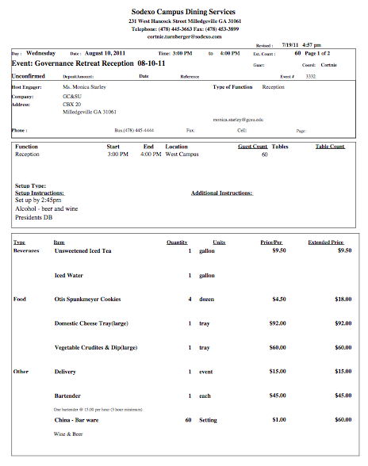
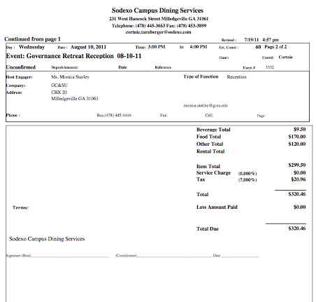

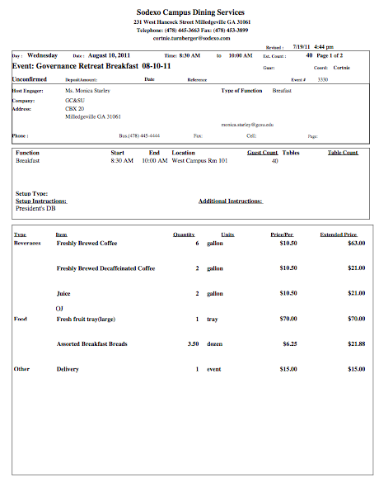

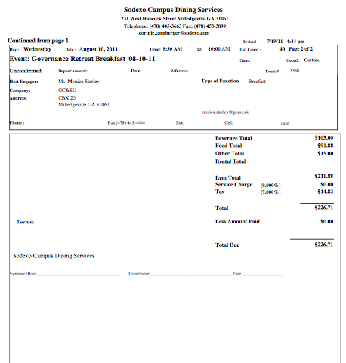

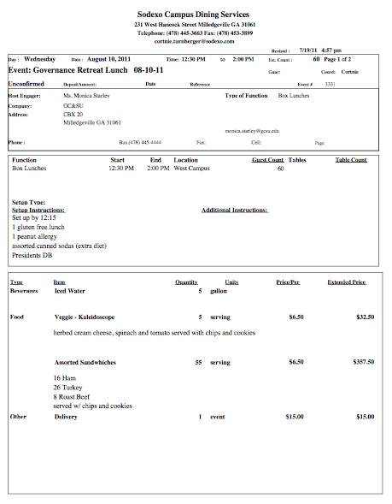

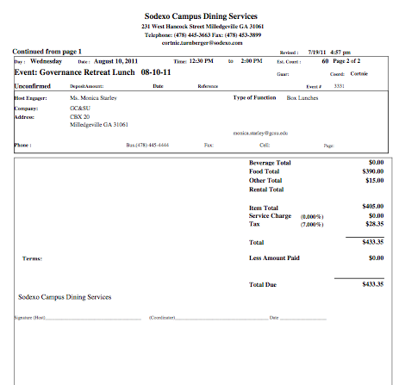

9:00 - 9:15 |  | Check-in Continental Breakfast |  | All Participants
9:15 - 9:20 | Welcome |  | Interim President Stas Preczewski
9:20 - 9:30 | Recognitions |  | Ken McGill and Stas Preczewski
9:30 - 10:30 | Parallel Session I - Orientation & History  Parallel Session I - Participation & Attendance |  | Mike Rose/Craig Turner  Dean Baker/Karynne Kleine
10:30 - 11:20 | Parallel Session I – Parliamentary Procedure (Advanced)  Parallel Session II – Parliamentary Procedure (Basic) |  | Ken Farr  David Muschell, University Senate Parliamentarian
11:20 - 12:15 | Issue-framing Activity and Discussion |  | Jan Clark, Senate Presiding Officer
12:15 – 12:45 | Lunch |  | Sodexo
12:50 – 1:00 | Lunch Activity – Getting to Know Your Fellow Senators |  | Jennifer M. Flory
1:00 – 1:30 | Standing Committee Synthesis |  | Amy Pinney (APC)  Ryan Brown (CAPC)  Craig Turner (FAPC)  Dianne Chamblee (SAPC)  Judith Malachowski (RPIPC)  Other (Karynne Kleine)
1:30 – 1:45 | Evaluation and Reflection |  | Liz Havey/Lee Gillis
1:45 – 3:00 | University Senate Meeting |  | Jan Clark
3:00 – 4:00 | Celebration and Social  All Participants |  | All Participants
University Senate Orientation Manual, which informs the Orientation Session, is available at 2011 Governance Retreat Web Presence: http://info.gcsu.edu/intranet/univ_senate/Retreat_11/
Thanks to the Governance Retreat Members: Dean Baker, Karynne Kleine, Mike Rose, Craig Turner, Dee Sams and the Session Facilitators
10 August 2011 9:00 a.m. to 4:00 p.m. West Campus Center
“Pumping up the Flow: Shared Governance as the Heart of GC”
Appendix E – Agenda, Survey and Anecdotal Table
University senate governance retreat evaluation form

INSTRUCTIONS: Please select a response that indicates the quality of each session as to its influence on your effectiveness as a University Senator by ranking each session with 5 = Most Effective and 1 = Completely Ineffective Please circle zero if you did not attend a session. Circle ONLY one number for each session. Comments detailing the reasoning for your choices will be most useful.
 |  |  | Not applicable | Completely Ineffective | Ineffective | Somewhat Effective | Effective | Most Effective
Parallel Session I - Orientation & History |  |  | 0 | 1 | 2 | 3 | 4 | 5
Comments:
Parallel Session I - Participation & Attendance |  |  | 0 | 1 | 2 | 3 | 4 | 5
Comments:
Parallel Session I – Parliamentary Procedure (Advanced) |  |  | 0 | 1 | 2 | 3 | 4 | 5
Comments:
Parallel Session II – Parliamentary Procedure (Basic) |  |  | 0 | 1 | 2 | 3 | 4 | 5
Comments:
Issue-framing Activity and Discussion |  |  | 0 | 1 | 2 | 3 | 4 | 5
Comments:
Lunch Activity – Getting to Know Your Fellow Senators |  |  | 0 | 1 | 2 | 3 | 4 | 5
Comments:
Standing Committee Synthesis |  |  | 0 | 1 | 2 | 3 | 4 | 5
Comments:

Appendix F - Anecdotal Impressions (2010) – University Senate
Standing Committee | Ratings
 | Not Active At all | Not Very Active | Cannot Judge | Moderately Active | Extremely Active*
CAPC | 10% | 10% | 20% | 20% | 40%
APC | 5% | 30% | 10% | 14% | 40%
FAPC | 0% | 5% | 30% | 40% | 25%
RPIPC | 5% | 5% | 20% | 40% | 30%
SAPC | 5% | 40% | 40% | 5% | 10%
Average | 5% | 18% | 24% | 24% | 29%
* Attends every meeting and volunteers for assignments

Appendix G – Excel Spreadsheet - Retreat Responses

Appendix H – Written Retreat Evaluations

1. Parallel I: Orientation & History (Rose/Turner)
- Venue made it difficult to hear.
- Space was not the best for this session
- Excellent job by Craig and Mike
- Very difficult to hear, History disjointed & two speakers overlapped timeframe, would have preferred more active learning method.
- Hard to hear speakers
- Definitely helped introduce new senators and University Senate
2. Parallel I: Participation and Attendance (Baker/Kleine)
- Enjoyed brainstorming
- This session was really useful
- Good group discussions
- We should spend more time addressing these issues and the questions posed to the group. This should be passed to all members.
3. Parallel II: Parliamentary Procedures (Farr)
- Great as always.
- Ken’s efforts were great!
- It was good to discuss situations in which less used motions might be useful.
- Somewhat redundant
- Great example
4. Parallel II: Parliamentary Procedures (Muschell)
- David’s “Punch motion” was a great way to illustrate the lessons.
- Very effective. David was great.
- Very well-planned and simple
- Very fun
- Great! Very effective! Good “hands on” example!
5. Issue-framing Activity and Discussion [Exam Schedule] (Clark)
- Exam Schedule?
- Ours was an angry group, but I’m glad group 2 excelled.
- Good use of time; discussing the options for a new exam schedule.
- ?Did we do this? Perhaps just cut this part altogether
- Would have liked more time
- Good discussion topics and facilitators.
6. Lunch: Getting to Know Your Fellow Senators (Flory)
- Super!
- I’m not a big fan of these
- Friendly participants!
- I’m not sure of anything better, but very few people participated.
- Insufficient time.
7. Standing Committee Synthesis (Kleine)
- It was good to meet and pre-plan
- Nice meeting everyone, but probably could have waited to first official meeting
- Well done, quick & to the point.
- I’m glad to hear what will be on the table in the coming year.
- Good amount of time devoted to this (short & sweet)
- More goat setting
- Got a lot accomplished
8. Other Comments
- Different venue would have been helpful. Too much noise where groups met from other groups.
- I just have to clarify that I’m not a senator, so that skews my answers. As a committee member I was told to attend but the sessions weren’t relevant, particularly to those of us who serve on committees but aren’t senators (Rater 5)
- Can you shorten it?
- Retreat should start later for returning senators. Session I more relevant for new senators.
- Overall, I thought today was very organized
- Last year we told you that lunch was BAD – especially the vegetarian option & you said you’d improve it for this year. But this year’s veg. option was exactly the same – and equally BAD. Please try to improve this for next year. Otherwise a fairly good (thorough long) day. It seemed esp. long coming after a FULL day of meetings yesterday [Assessment Day].

