Standing Committee Officers Orientation
How to Navigate the Senate Website
Senate Website (https://senate.gcsu.edu/)
University Senate Management System: Log in with UNIFY username and password
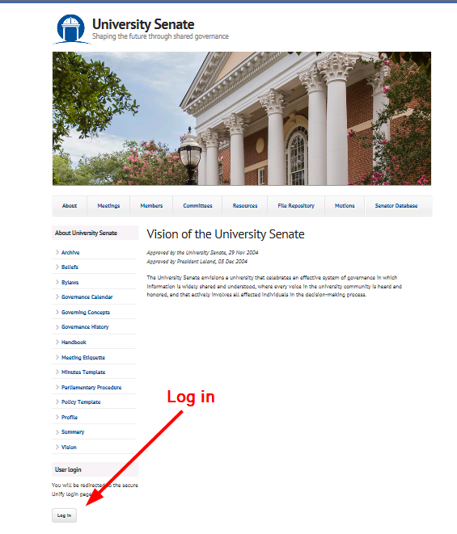

- Accessing and Utilizing the Motion Database

Access Motion Database

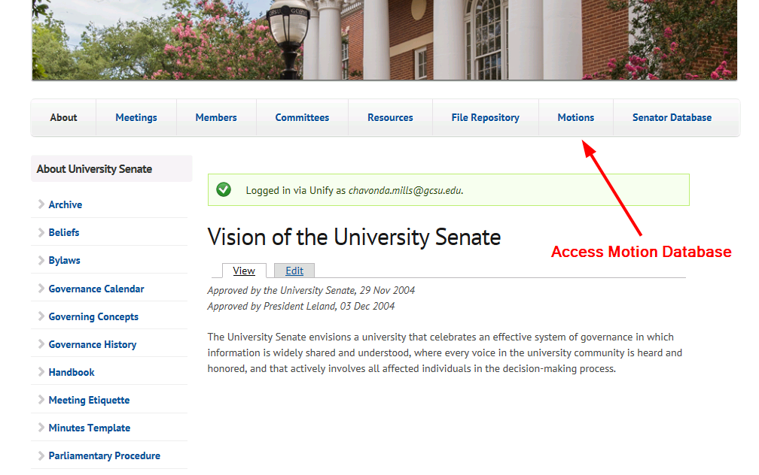

Add New Motion

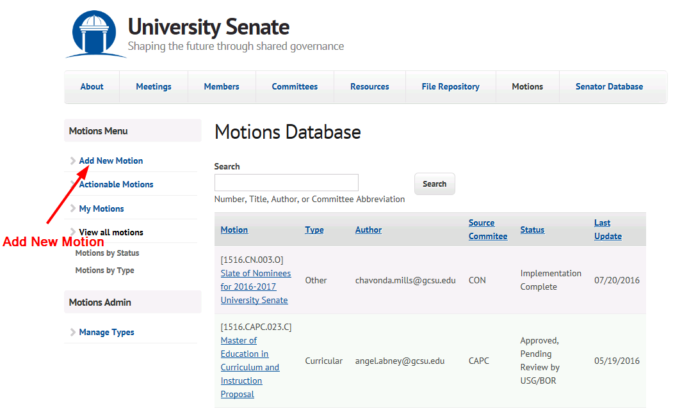
Complete Motion Entry Form and Save
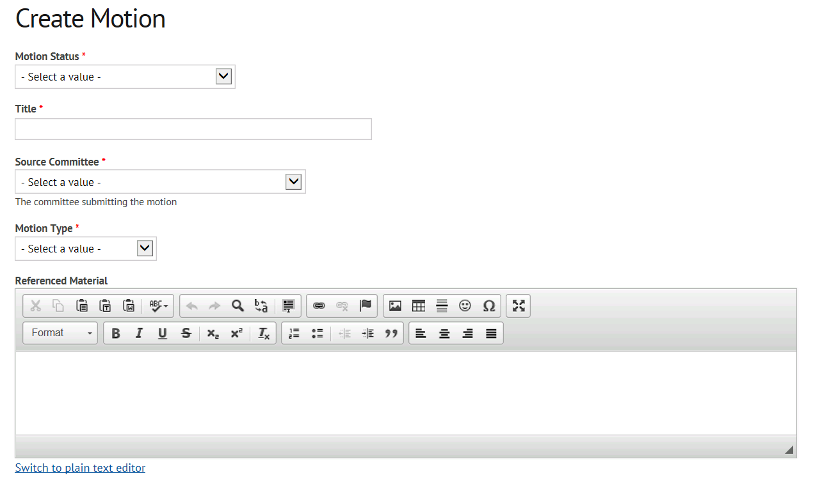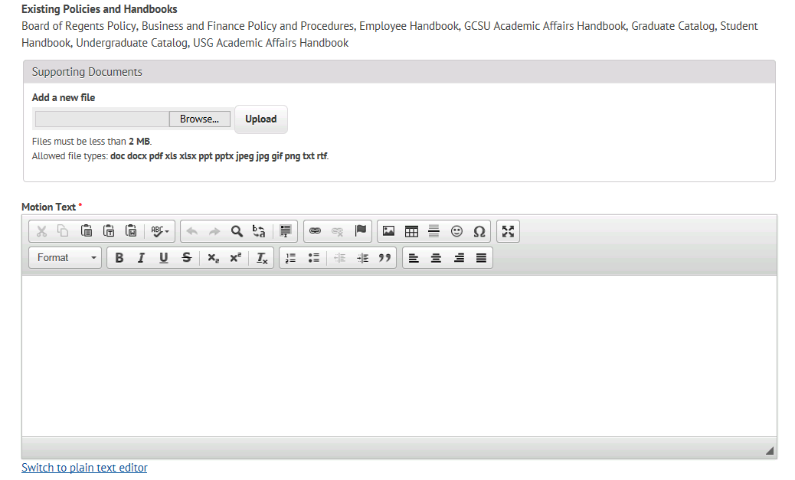

- Accessing and Submitting Meeting Agenda through the File Repository
Access File Repository
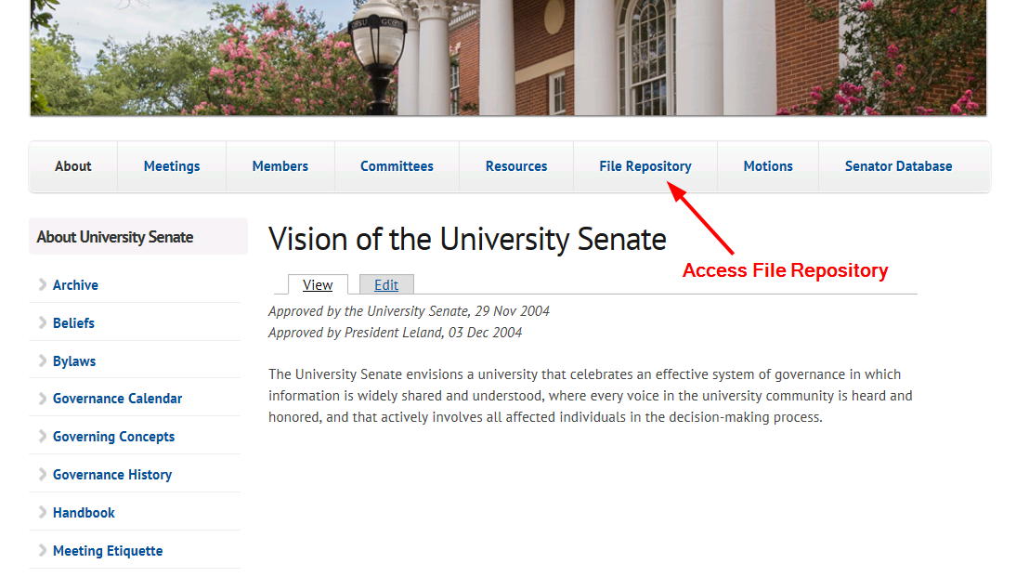
Select File Type, Public or Private
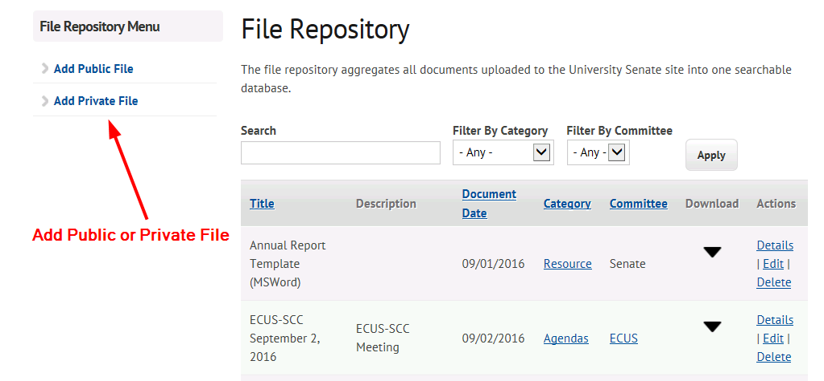

Complete Create Document Form and Save
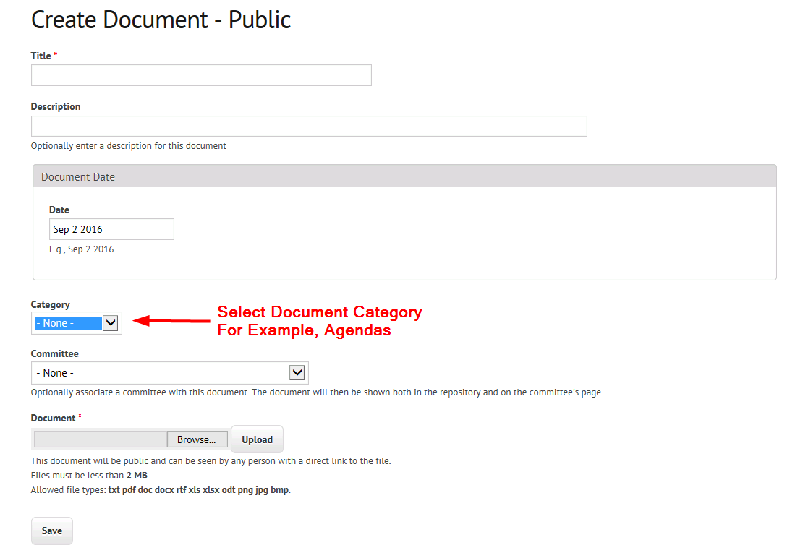

- Submission of Minutes
Access Minutes
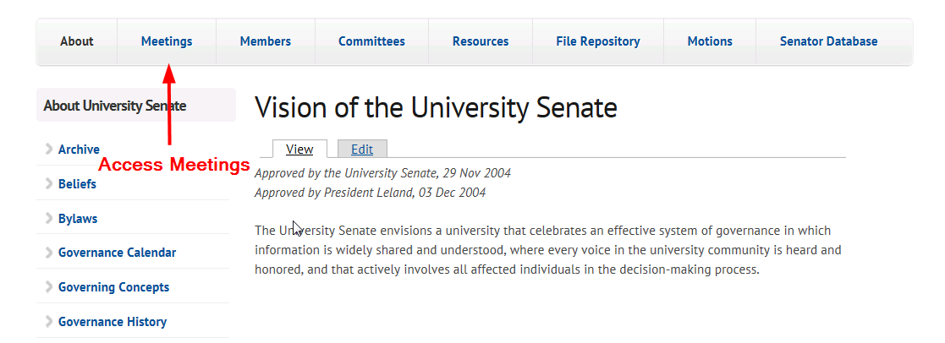
Add Minutes
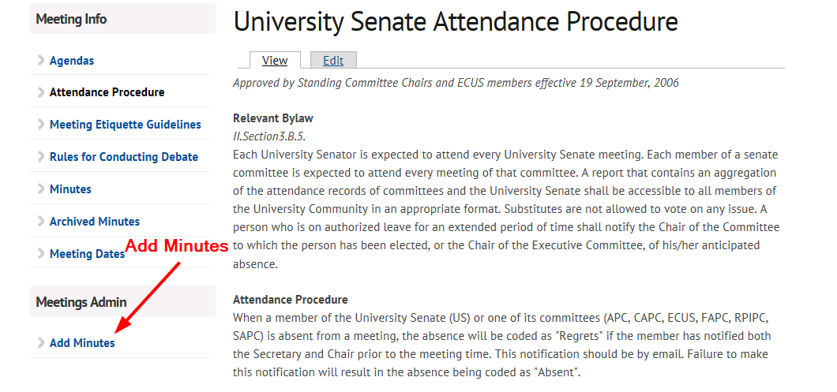

Complete Meeting Record with Minutes Form
